
Animal-Clinic Test Plan
420-DW4-AS Web Server Applications Development II

December 4, 2025
Rafat-Ahmed Islam (2311953), Shaquille Osborne Neil (2330041), Kevin Alinazar (2332512), Alvaro Eloy Limaymanta Soria (2311145)
Presented to

Professor
Houria Houmel

Contents
Figure 1 – Login Page 4
Figure 2 – Administrator Dashboard 5
Figure 3 – Veterinarian Dashboard 6
Figure 4 - Receptionist Dashboard 7
Figure 5 - Owners List Page 8
Figure 6 - Create New Owner Page 9
Figure 7 – Edit Owner Page 10
Figure 8 – Owner Details Page 11
Figure 9 – Delete Owner Confirmation Page 12
Figure 10 – Create Owner Validation Errors 13
Figure 11 - Animals List Page 14
Figure 12 - Create New Animal Page 15
Figure 13 – Edit Animal Page 16
Figure 14 - Animal Details Page 17
Figure 15 - Delete Animal Confirmation Page 18
Figure 16 - Create Animal Page with Validation Errors 19
Figure 17 – Veterinarians List Page 20
Figure 18 - Create New Veterinarian Page 21
Figure 19 – Edit Veterinarian Page 22
Figure 20 - Veterinarian Details Page 23
Figure 21 – Delete Veterinarian Page 24
Figure 22 – Appointments Page 25
Figure 23 - Create New Appointment Page 26
Figure 24 - Edit Appointment Page 27
Figure 25 – Appointments Details Page 28
Figure 26 – Delete Appointment Page 29
Figure 27 – Create New Appointment (Validation Errors) 30
Figure 28 – Veterinarian Schedule Overview 31
Figure 29 – Create new Veterinarian Schedule 32
Figure 30 – Edit Veterinarian Schedule 33
Figure 31 – Schedule Details 34
Figure 32 – Delete Schedule 35
Figure 33 - Medical Histories Overview 36
Figure 34 – Create Medical History Record 37
Figure 35 – Edit Medical History Record 38
Figure 36 – Medical History Details 39
Figure 37 - Delete Medical History Confirmation Page 40
Figure 38 - Notifications Management Interface 41
Figure 39 - Create New Notification Form 42
Figure 40 – Edit Notification Page 43
Figure 41 – Notification Details Page 44
Figure 42 – Delete Notification Page 45
Figure 43 - Create Notification Page with Validation Errors 46
Figure 44 – Daily Agenda View 47
Figure 45 – Monthly Reports View 48
Figure 46 – User Accounts Management View 49
Figure 47 – Create User Account View 50
Figure 48 – Edit User Account 51
Figure 49 - User Account Details 52
Figure 50 – Delete User Account 53
Figure 51 – User Roles List 54
Figure 52 – Create New Role 55
Figure 53 – Edit Role 56
Figure 54 – Role Details 57
Figure 55 – Delete Role 58
Figure 56 – Create New Role (Validation Error) 59

Figure 1 – Login Page

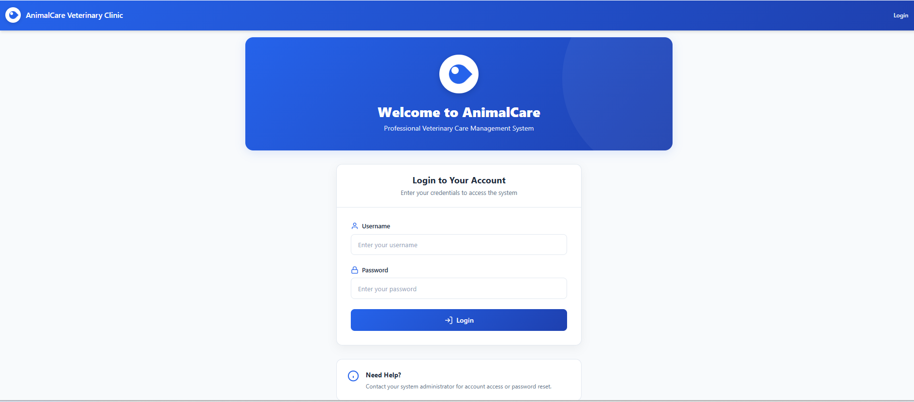

Figure 1 shows the login page of the system, where users must enter their credentials to access the application. Authentication is role-based, ensuring that only authorized users such as administrators, veterinarians, and receptionists can use the system.

Figure 2 – Administrator Dashboard

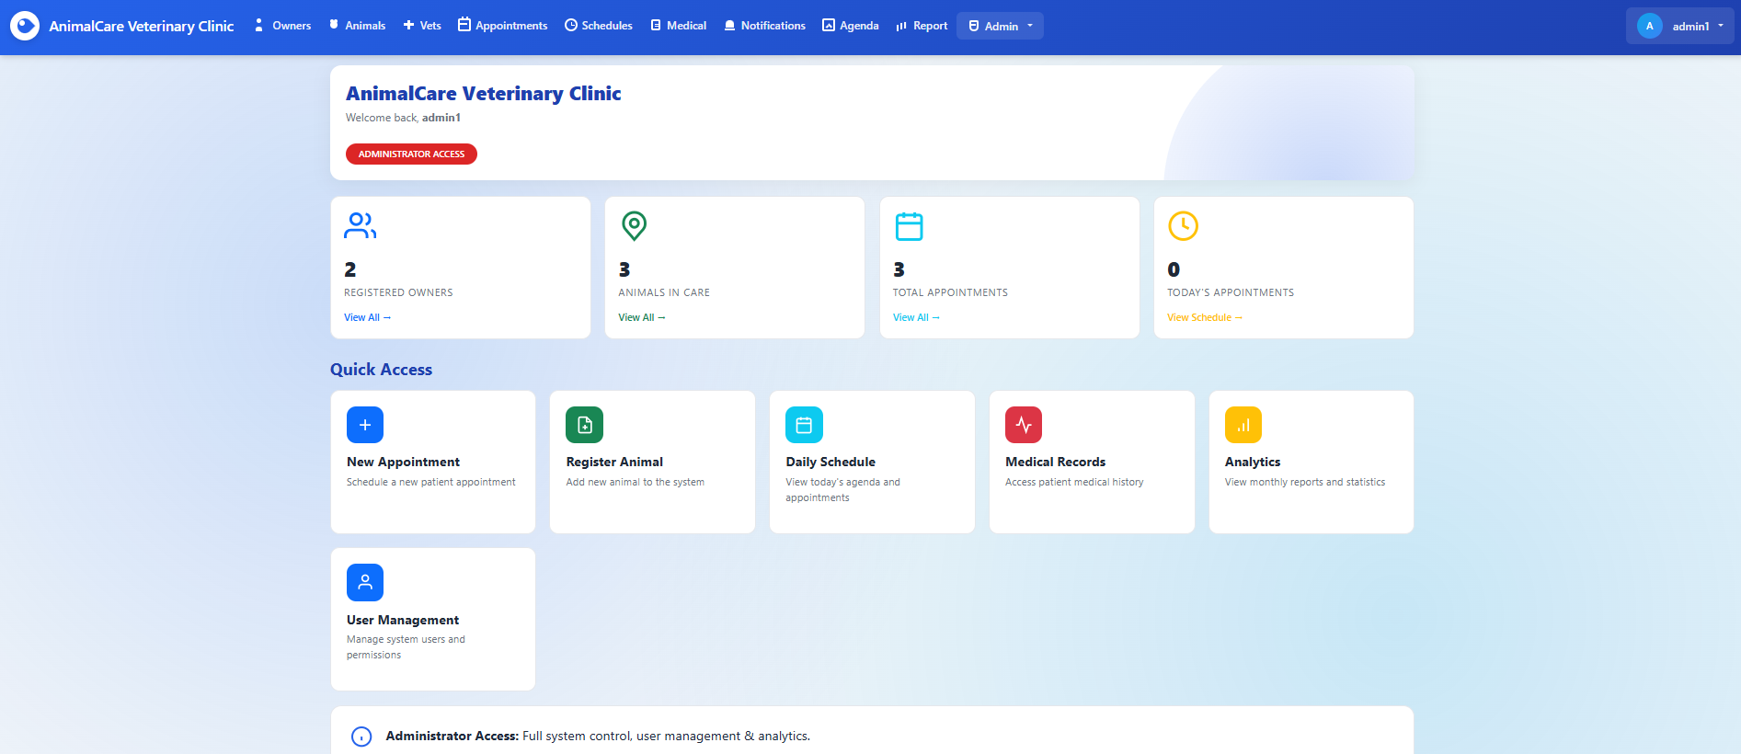

Figure 2 displays the administrator dashboard, which provides full system access including user management, appointment scheduling, medical records, and reporting features. Administrators can view system-wide statistics and navigate quickly to core management modules through the dashboard shortcuts.

Figure 3 – Veterinarian Dashboard

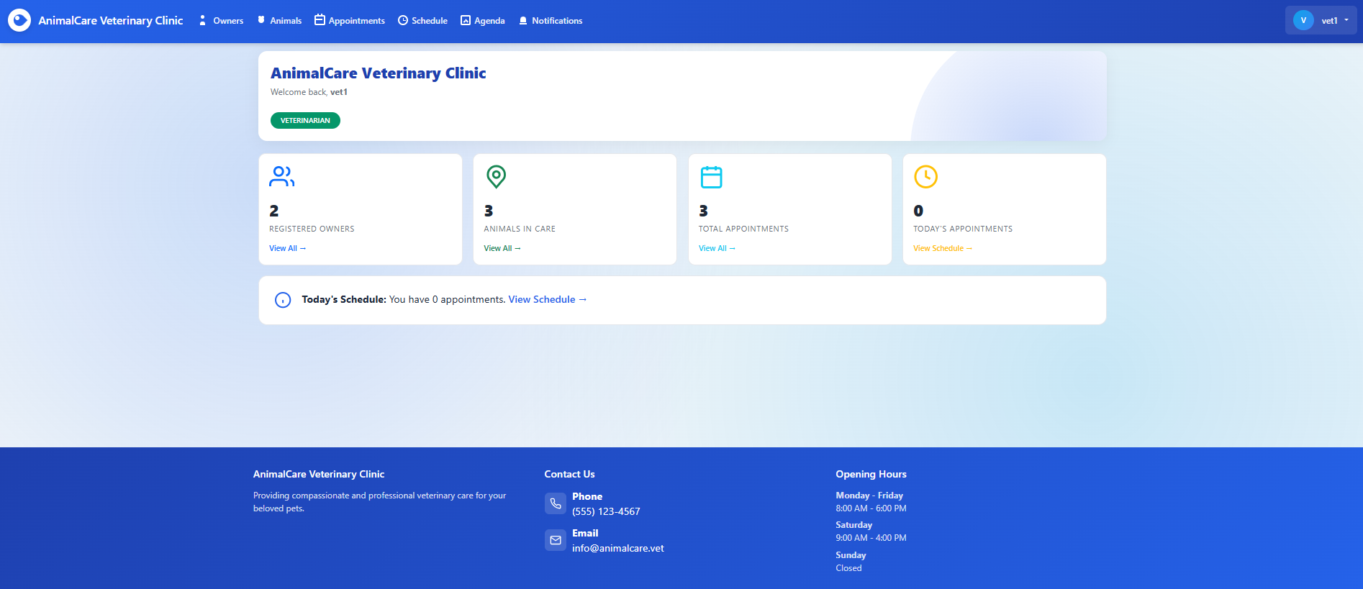

Figure 3 shows the veterinarian dashboard, where logged-in veterinarians can view key clinic statistics along with their daily schedule and upcoming appointments. This interface provides quick access to animals, owners, appointments, and notifications relevant to the veterinarian’s role.

Figure 4 - Receptionist Dashboard

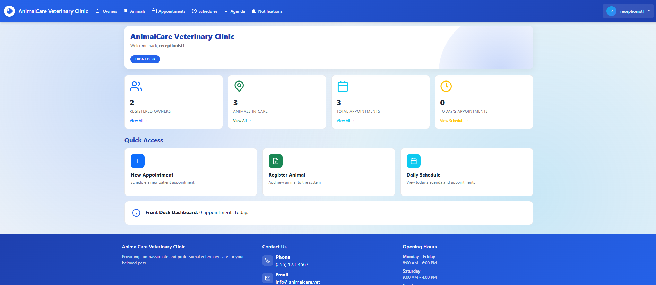
Figure 4 shows the receptionist dashboard, which provides quick access to core front-desk functions such as booking new appointments, registering animals, and viewing the daily schedule. This interface is designed to streamline client interactions and support efficient appointment coordination.

Figure 5 - Owners List Page

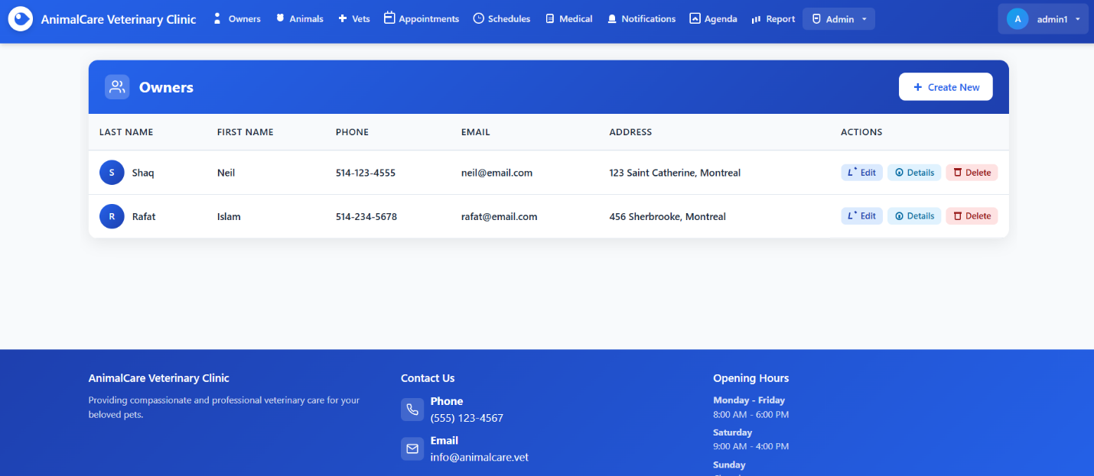

Figure 5 displays the Owners management page, where administrators and receptionists can view all registered owners along with their contact information. From this interface, users can create new owner records or perform edit, details, and delete operations for existing entries.

Figure 6 - Create New Owner Page
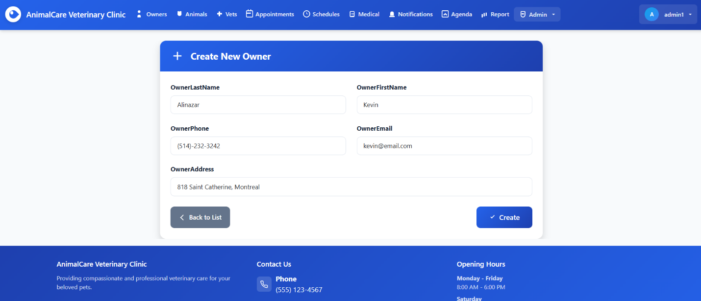
Figure 6 shows the form used to register a new owner in the system, allowing staff to input essential details such as name, phone number, email, and address. After submitting the form, the new owner is added to the database and becomes available for linking with animal records and appointments.

Figure 7 – Edit Owner Page
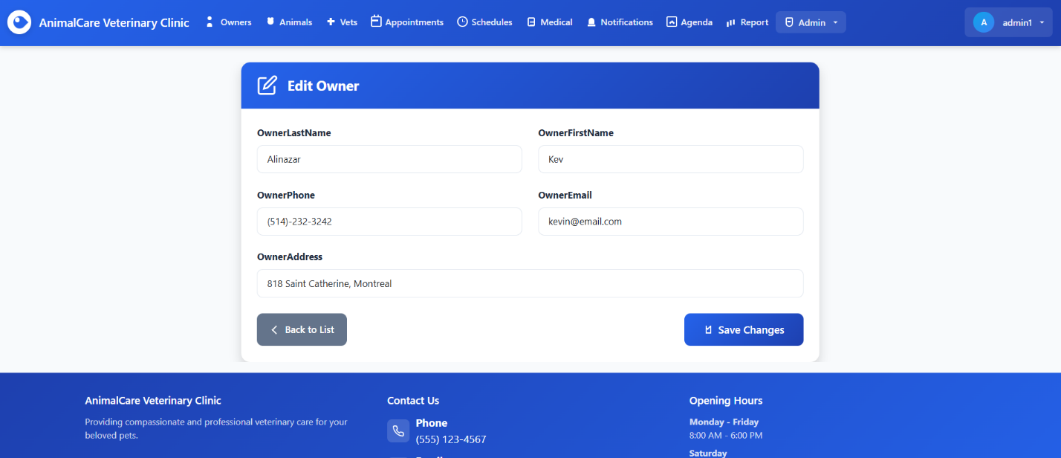
Figure 7 shows the edit form used to modify an existing owner's information, allowing staff to update fields such as name, contact details, and address. Once changes are saved, the updated data is written back to the database, ensuring the owner's profile remains accurate and up to date.

Figure 8 – Owner Details Page
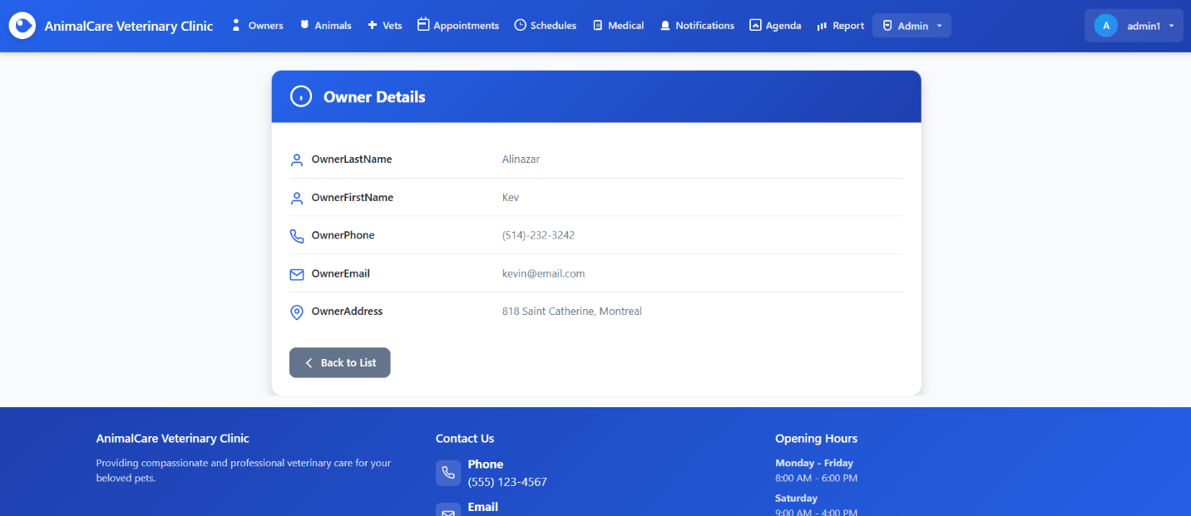
Figure 8 presents the owner details view, where staff can review all stored information about a specific owner, including contact details and address. This page provides a read-only summary useful for verifying data before performing actions such as editing, deleting, or registering new animals under that owner.

Figure 9 – Delete Owner Confirmation Page
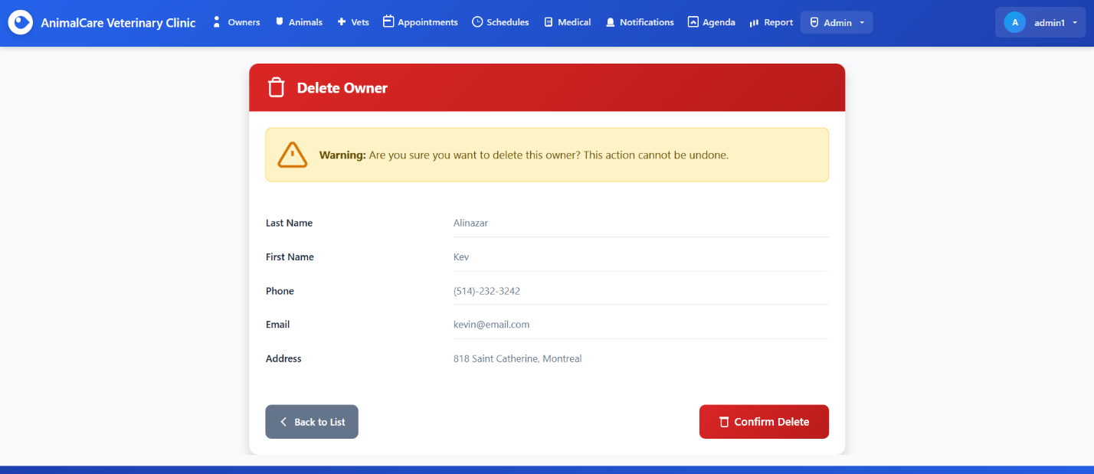
Figure 9 displays the delete confirmation page, where the system presents the owner's information and asks the user to confirm the deletion. This step prevents accidental data loss by requiring explicit confirmation before permanently removing the owner and any related records from the database.

Figure 10 – Create Owner Validation Errors
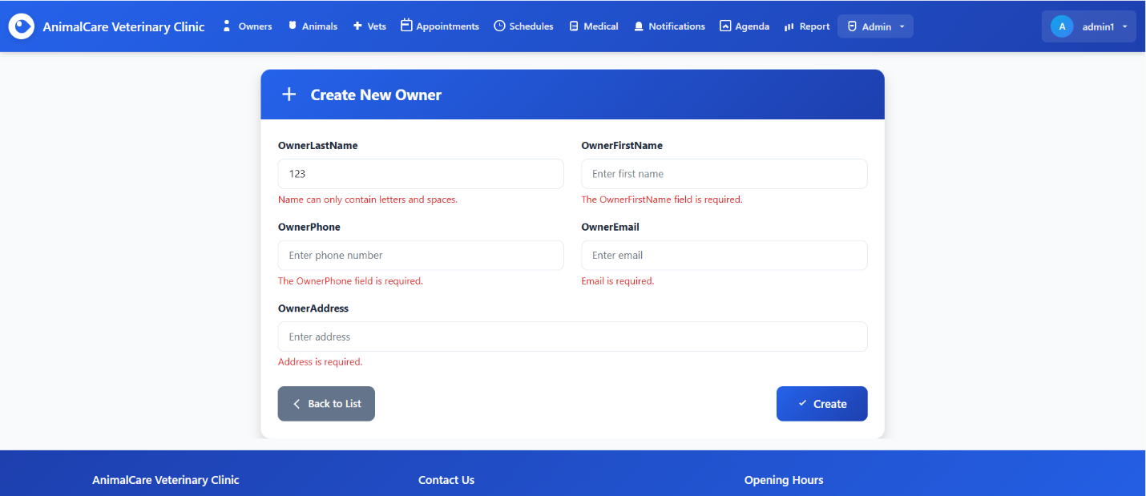
Figure 10 demonstrates the form validation system, which displays error messages when required fields are left empty or contain invalid data. This ensures that only properly formatted and complete owner information is submitted to the database, maintaining data quality and consistency.

Figure 11 - Animals List Page
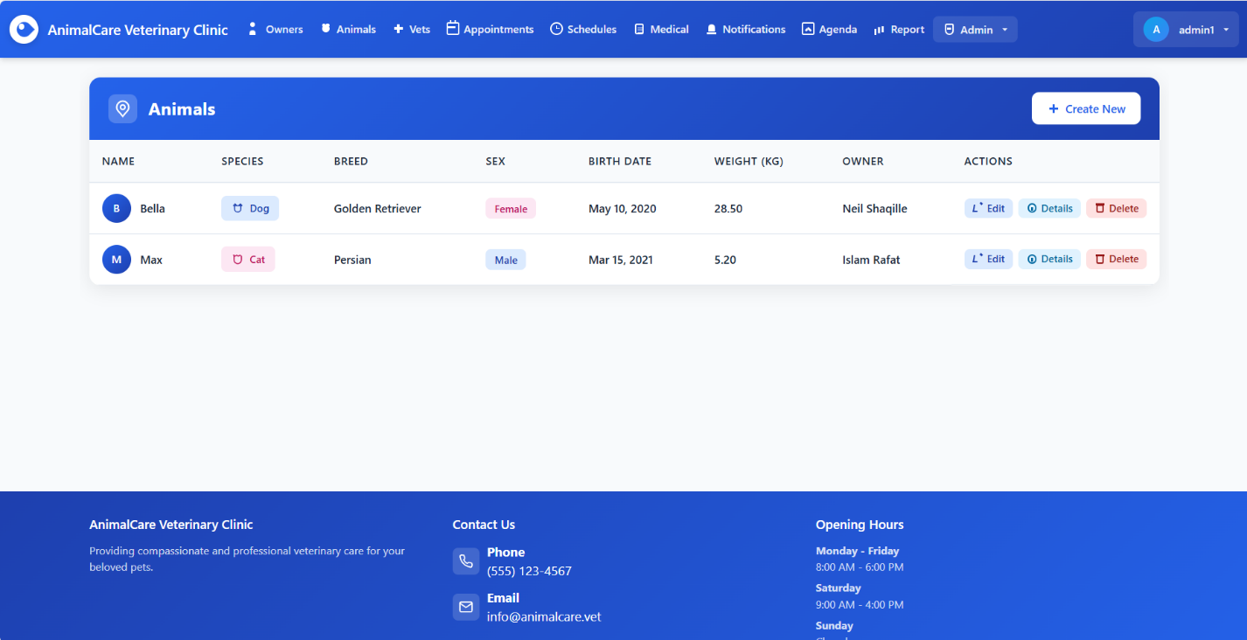
Figure 11 displays the Animals management page, where staff can view all registered animals along with key details such as species, breed, sex, birth date, weight, and owner. From this interface, users can create new animal records or access edit, details, and delete actions for existing entries.

Figure 12 - Create New Animal Page
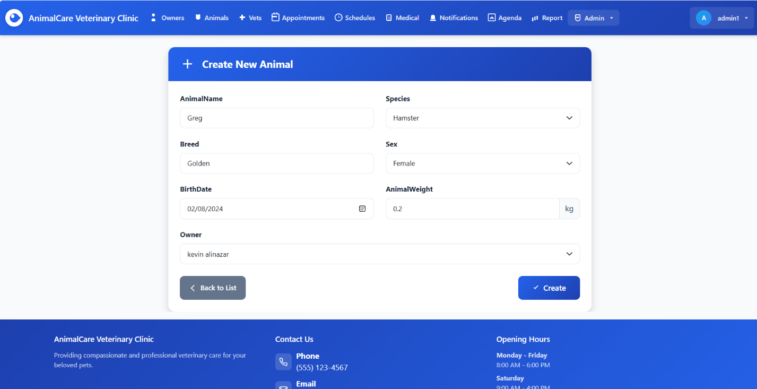
Figure 12 shows the form used to register a new animal, where staff can enter details such as the animal's name, species, breed, sex, birth date, weight, and associated owner. After submitting the form, the new animal is added to the system and becomes available for scheduling appointments and recording medical history.

Figure 13 – Edit Animal Page
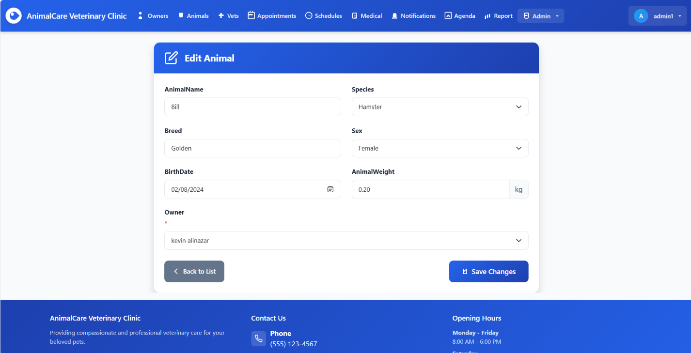
Figure 13 shows the edit form used to update an existing animal’s information, including species, breed, sex, birth date, weight, and associated owner. This allows staff to correct or modify animal records while ensuring the updated data remains consistent throughout the system.

Figure 14 - Animal Details Page
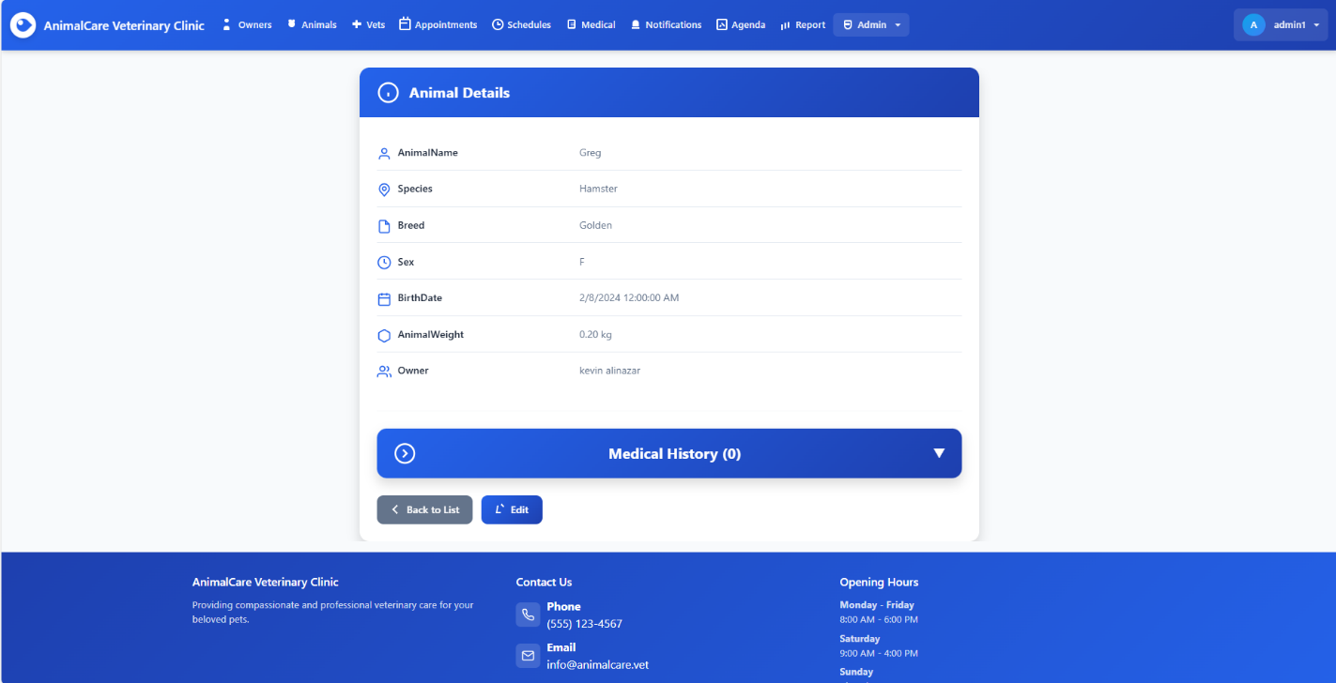
Figure 14 presents the detailed view of an animal’s profile, displaying all stored information such as species, breed, sex, birth date, weight, and associated owner. This page also provides access to the animal’s medical history section, allowing staff to review past consultations or add new medical records when needed.

Figure 15 - Delete Animal Confirmation Page
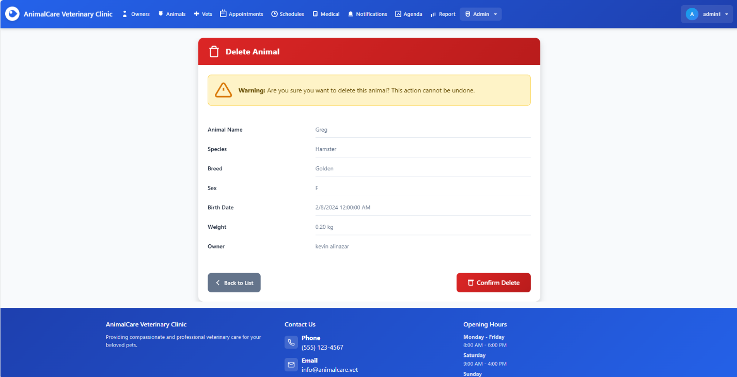
Figure 15 displays the delete confirmation page for an animal record, showing all key details and prompting the user to confirm the deletion. This safeguard ensures that staff intentionally approve the removal, preventing accidental loss of important animal and medical information.

Figure 16 - Create Animal Page with Validation Errors
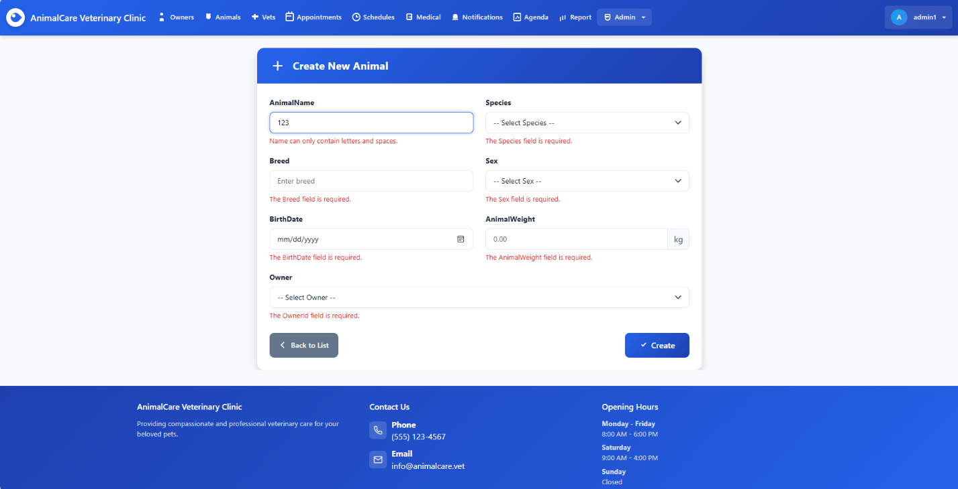
Figure 16 shows the Create New Animal form with client-side and server-side validation actively displayed. When the user submits incomplete or invalid information, the system highlights each required field with clear error messages. This ensures that all necessary animal data, including name, species, sex, weight, breed, birth date, and owner is correctly provided before the record can be created.

Figure 17 – Veterinarians List Page
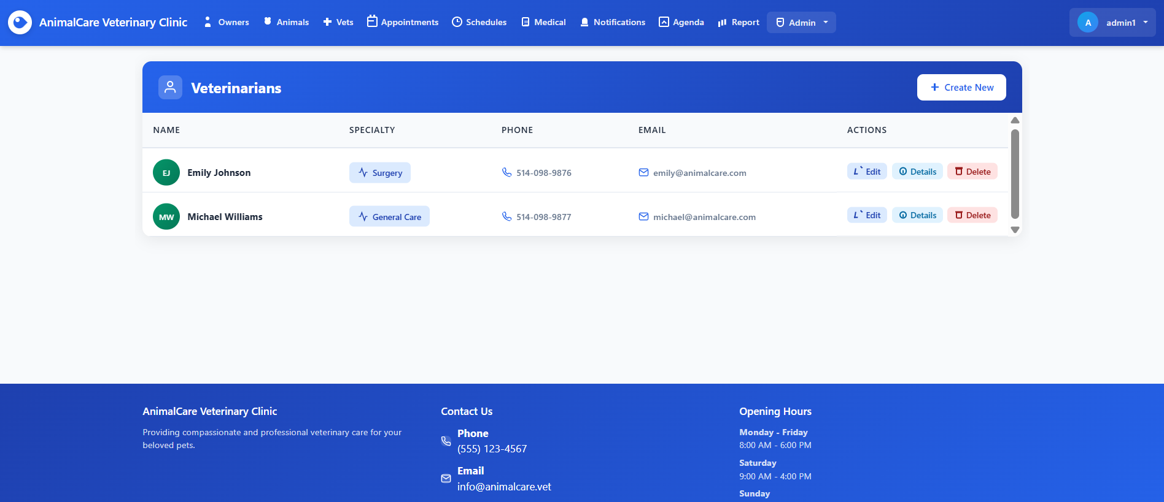
Figure 17 displays the Veterinarians management page, where all registered vets are listed in a clean, user-friendly table. Each row shows the veterinarian’s name, specialty, phone number, and email, along with action buttons that allow the admin to Edit, View Details, or Delete the selected vet. The page also includes a Create New button that lets administrators add new veterinarians to the system.

Figure 18 - Create New Veterinarian Page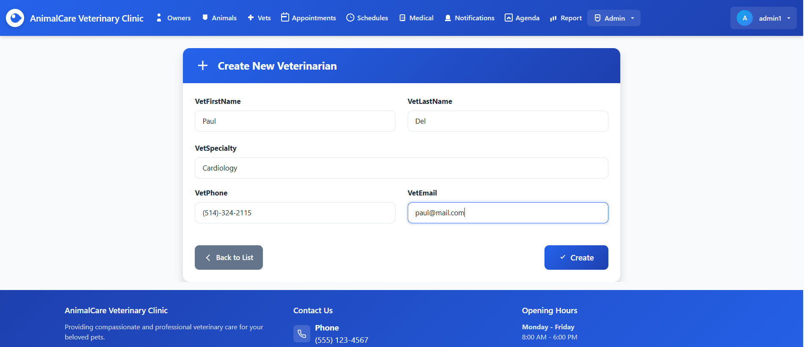
Figure 18 shows the Create New Veterinarian form where administrators can add a new veterinarian to the system. The form collects essential details such as first name, last name, specialty, phone number, and email. After entering all required information, the user can click Create to save the new veterinarian or use Back to List to return without making changes.

Figure 19 – Edit Veterinarian Page
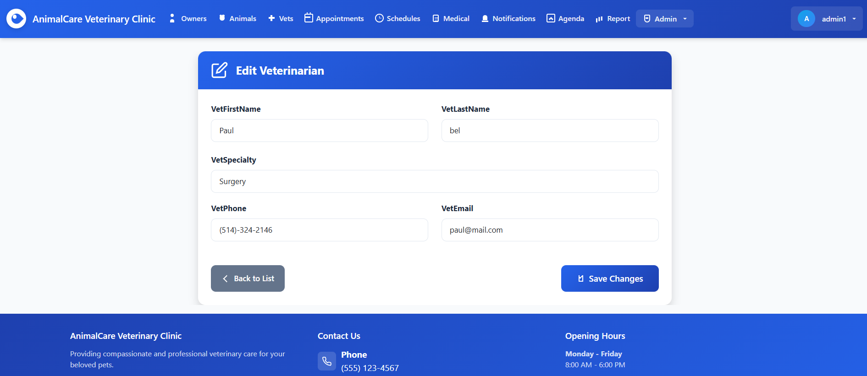
Figure 19 displays the Edit Veterinarian interface, where administrators can update an existing veterinarian’s information. The page provides editable fields for first name, last name, specialty, phone number, and email. After making any corrections or updates, the user can select Save Changes or return to the veterinarian list using Back to List.

Figure 20 - Veterinarian Details Page
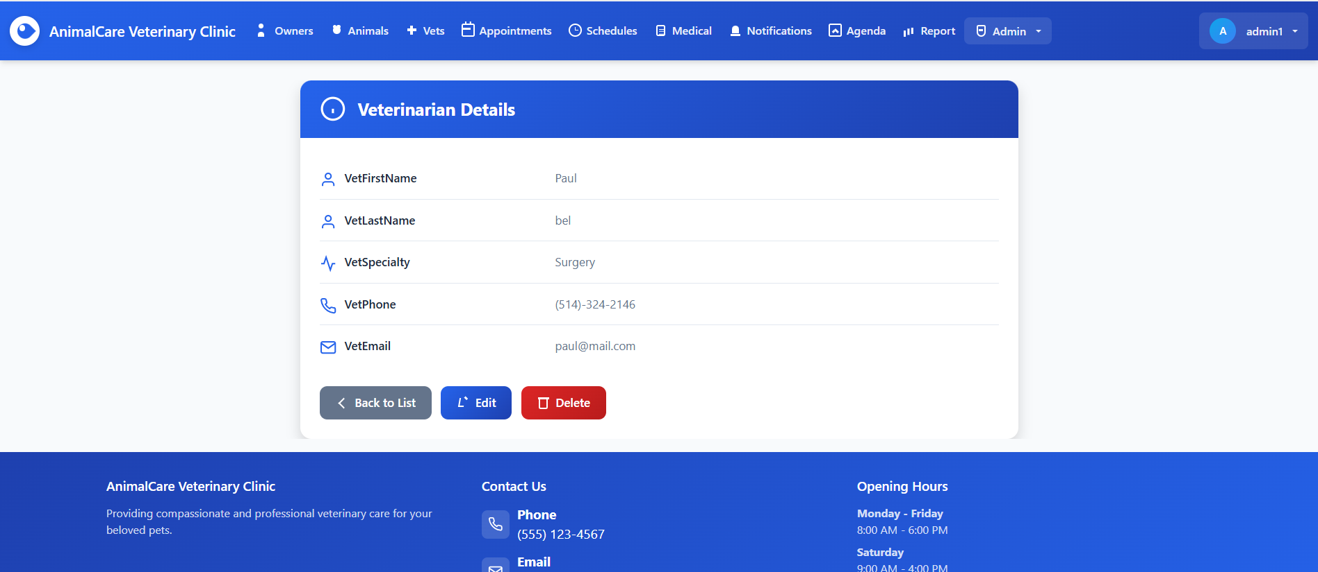
Figure 20 shows the Veterinarian Details view, where users can see all stored information about a specific veterinarian, including first name, last name, specialty, phone number, and email. From this page, the user can return to the list, edit the veterinarian’s details, or delete the record.

Figure 21 – Delete Veterinarian Page
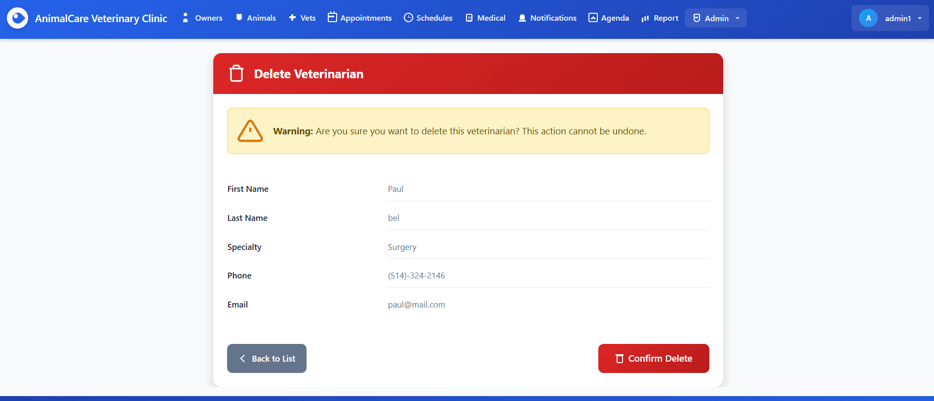
Figure 21 shows the delete confirmation page for a veterinarian. The system displays a warning message and the veterinarian’s information (first name, last name, specialty, phone, and email) so the user can review the record before deleting it. The user can either return to the list or confirm the deletion.

Figure 22 – Appointments Page
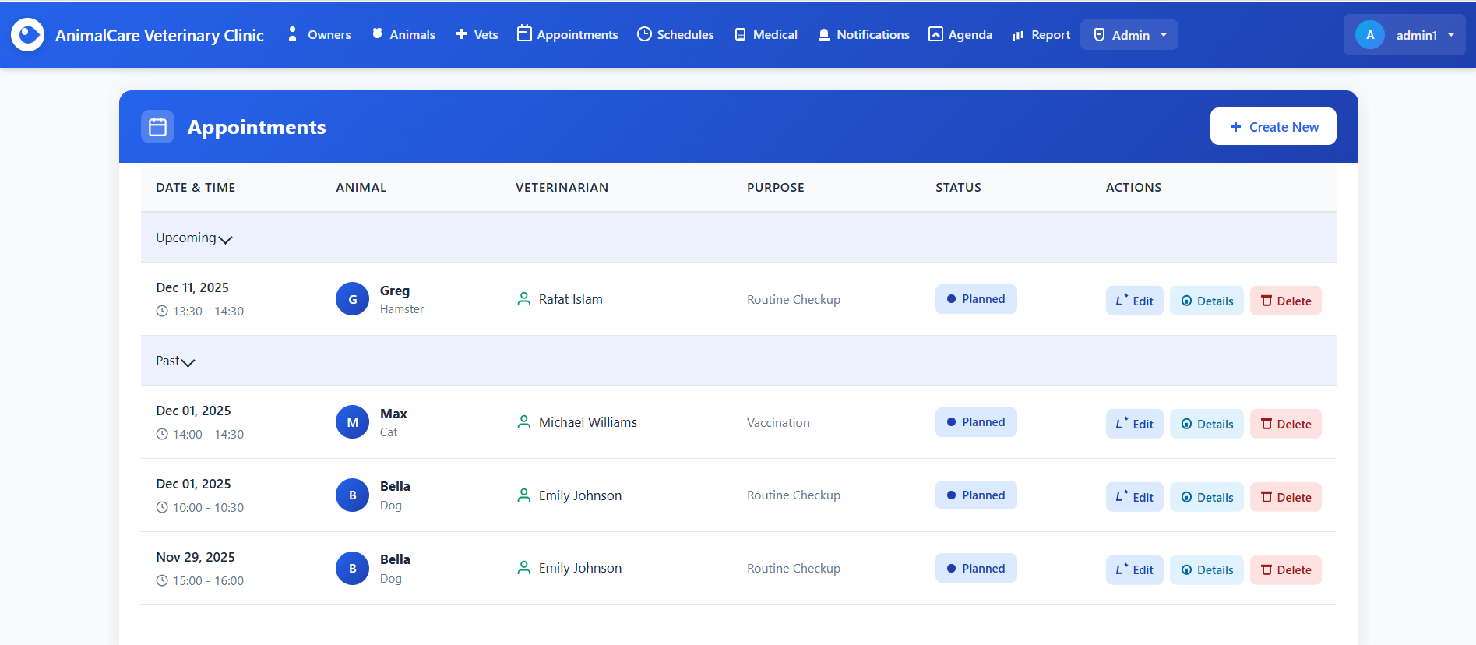
Figure 22 displays the appointments management interface, where all scheduled visits are organized into Upcoming and Past sections. Each appointment entry shows the date, time, animal, veterinarian, purpose, and current status. Users can quickly access action buttons to edit the appointment, view detailed information, or delete it. This page helps administrators efficiently monitor and manage all clinic appointments.

Figure 23 - Create New Appointment Page
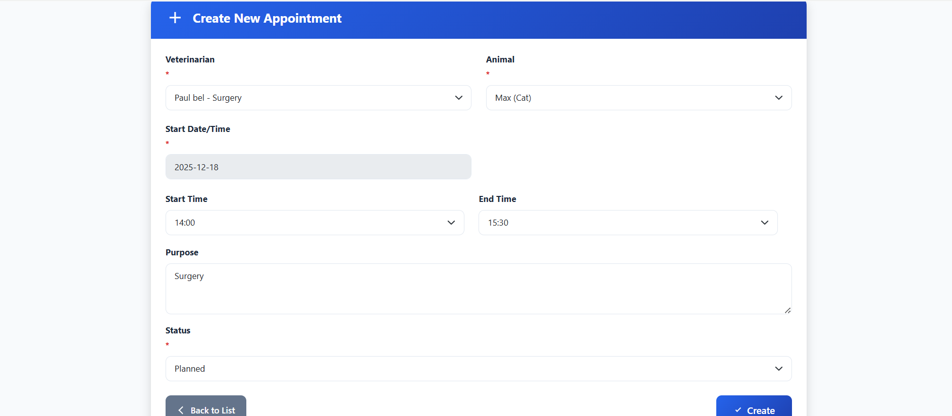
Figure 23 shows the form used to schedule a new appointment at the clinic. Users can select the veterinarian and animal involved, specify the appointment date, choose a start and end time, and enter the purpose of the visit. The form also includes a status selector to indicate whether the appointment is planned, completed, or canceled. A “Back to List” button provides quick navigation, while the “Create” button submits the new appointment to the system.

Figure 24 - Edit Appointment Page
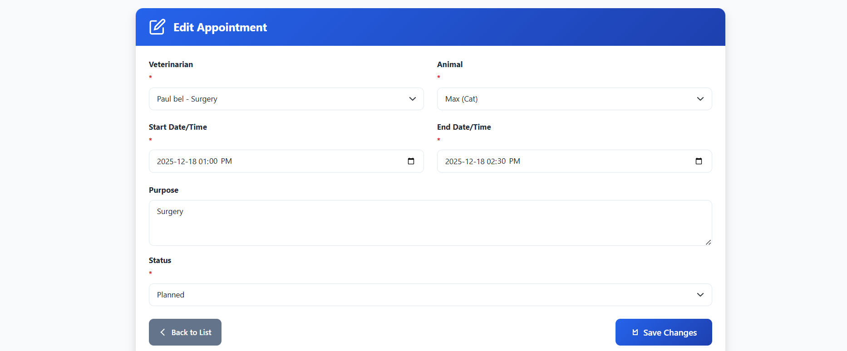
Figure 24 displays the interface for modifying an existing appointment. Users can update the assigned veterinarian, the selected animal, as well as the appointment’s start and end date/time. The form also provides fields to adjust the purpose of the visit and the appointment status. A “Back to List” button allows returning to the appointment overview, while the “Save Changes” button confirms and applies the updates.

Figure 25 – Appointments Details Page
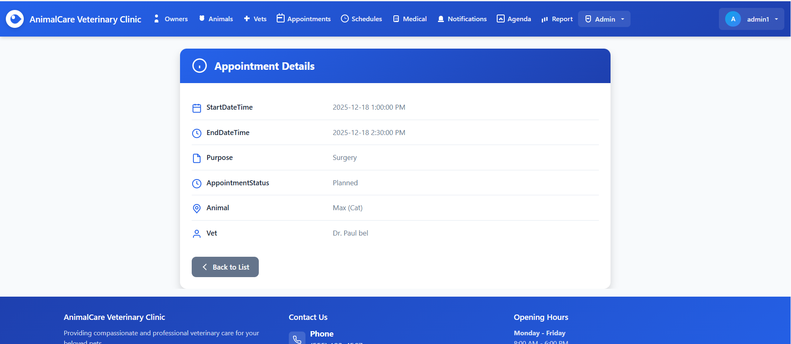
Figure 25 shows the detailed view of a specific appointment. The page displays the start and end date/time, purpose of the visit, and the current appointment status. It also identifies the associated animal and the assigned veterinarian. A “Back to List” button is provided to return to the appointment overview.

Figure 26 – Delete Appointment Page
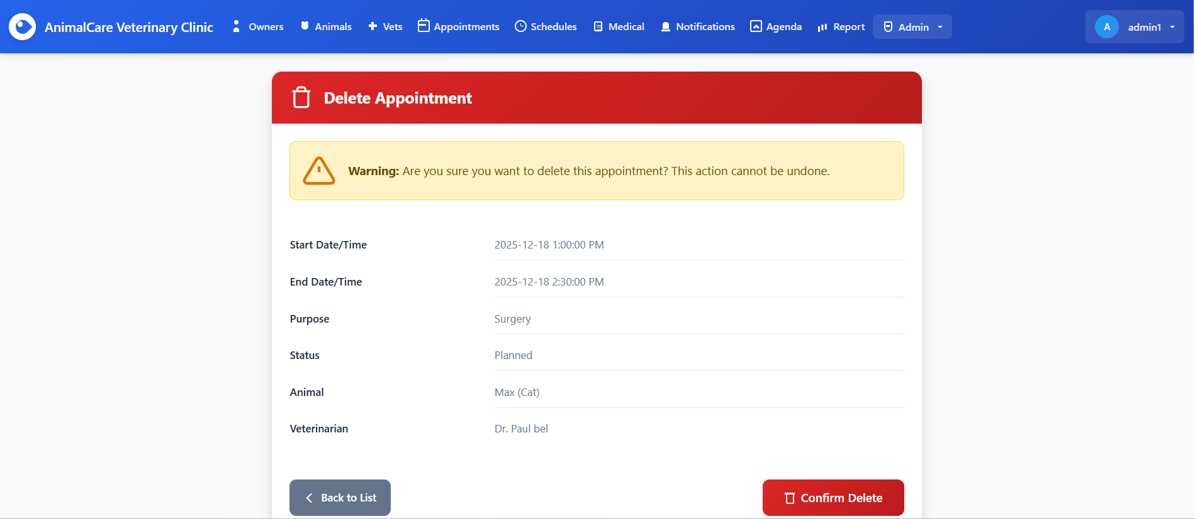
Figure 26 presents the delete confirmation page for an appointment. The interface displays a warning message notifying the user that this action is irreversible. All appointment details are shown, including start and end times, purpose, status, associated animal, and assigned veterinarian. The user can either return to the list or confirm the deletion.

Figure 27 – Create New Appointment (Validation Errors)
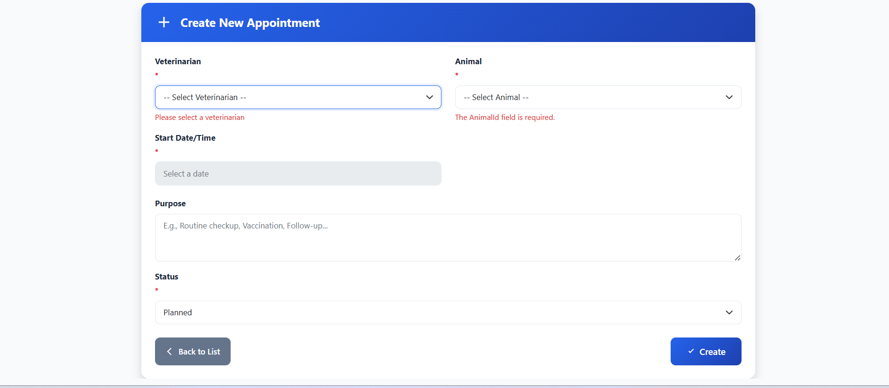
Figure 27 displays the appointment creation form with validation errors triggered. Required fields such as Veterinarian and Animal show red error messages when left unselected. Additional fields for date, purpose, and status are present, guiding the user to complete all necessary information before submitting.

Figure 28 – Veterinarian Schedule Overview
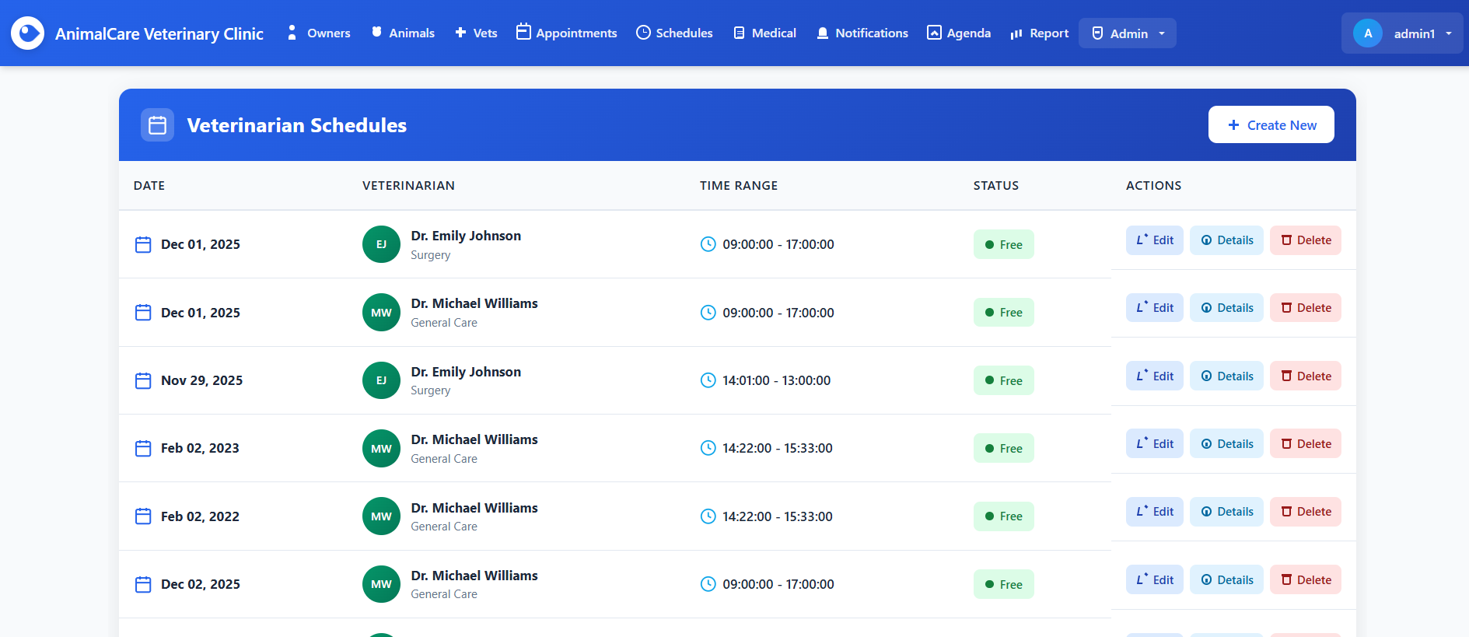
Figure 28 presents the Veterinarian Schedules page, displaying a list of scheduled working hours for each veterinarian. The table includes the date, veterinarian name and specialty, time range, and current availability status. Action buttons allow users to edit, view details, or delete each schedule entry. A “Create New” button at the top-right enables adding new schedule records.

Figure 29 – Create new Veterinarian Schedule
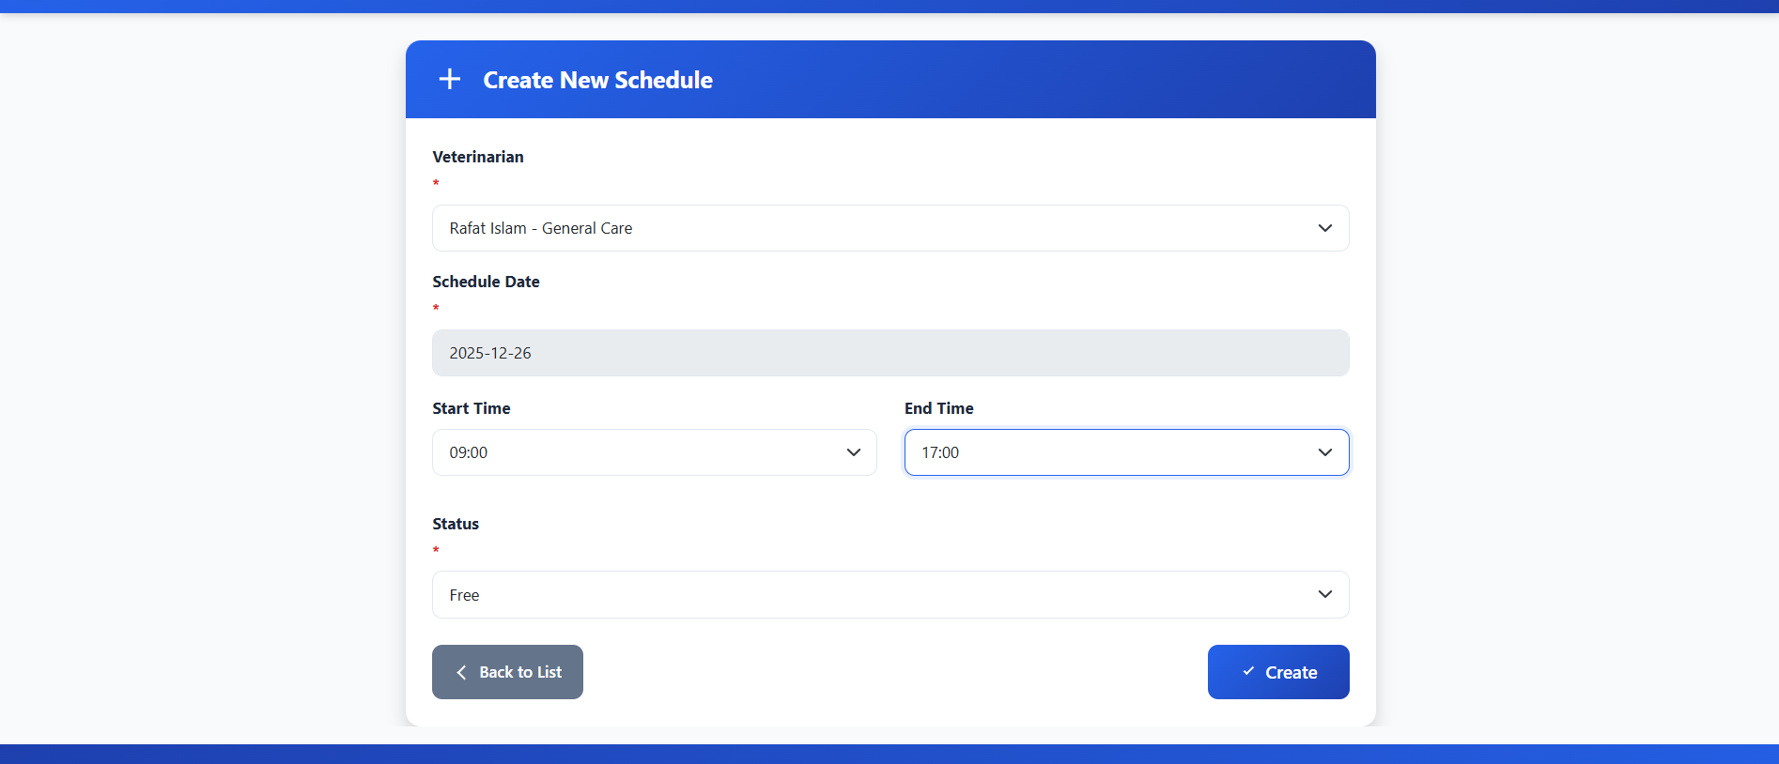
Figure 29 displays the form used to create a new veterinarian schedule. The user selects a veterinarian, chooses a schedule date, and specifies the working hours by selecting a start and end time. The schedule status (such as “Free”) is also chosen. A “Create” button submits the new schedule, while a “Back to List” button returns to the list of schedules.

Figure 30 – Edit Veterinarian Schedule
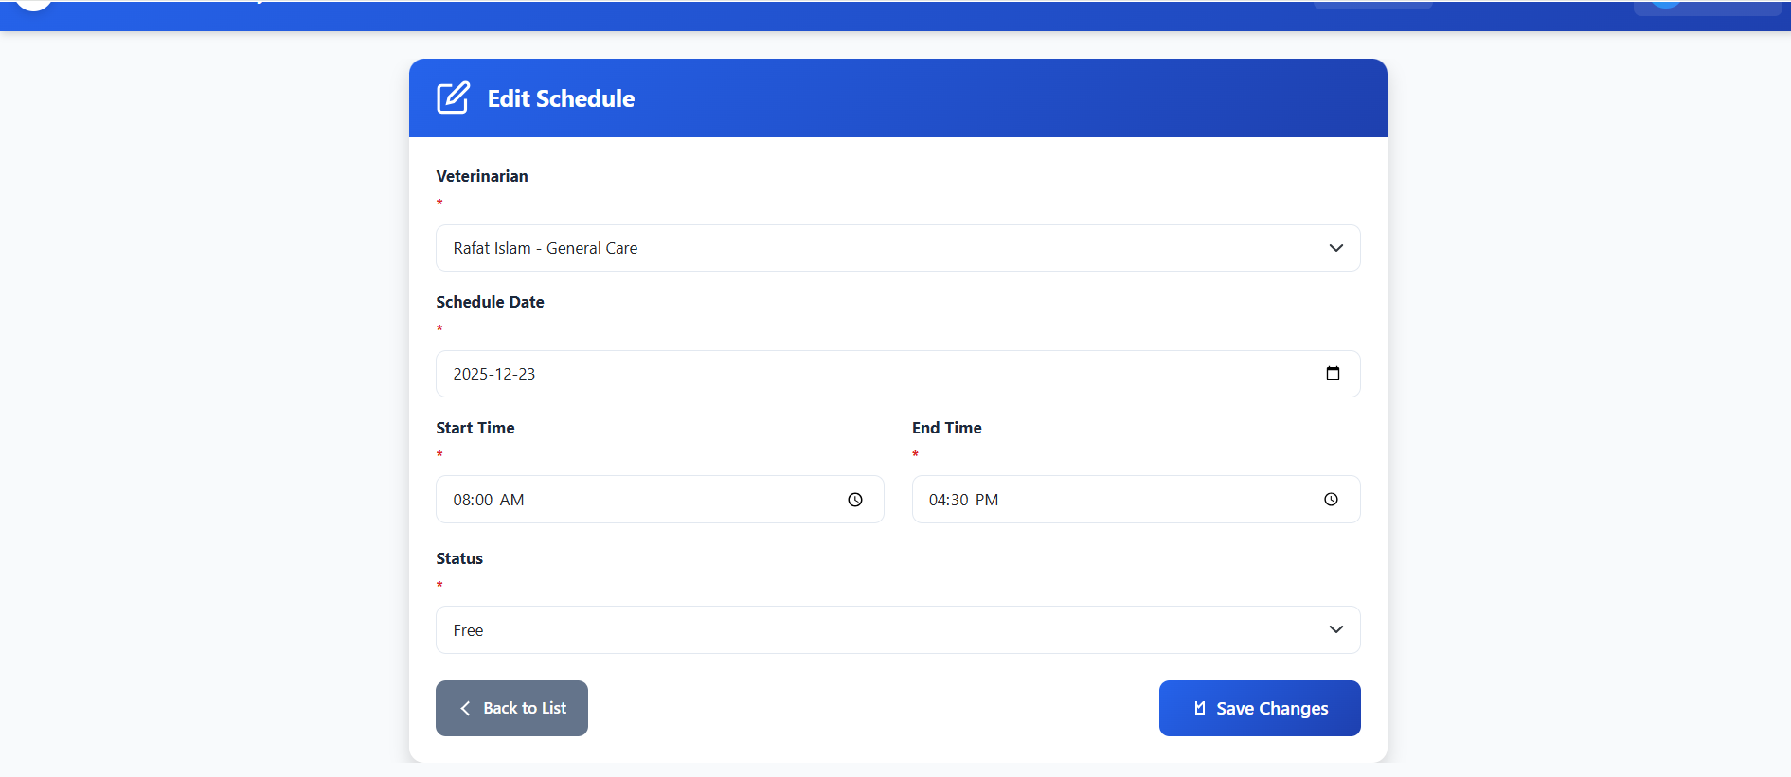
Figure 30 shows the interface used to edit an existing veterinarian schedule. The form allows the user to modify the veterinarian assigned, adjust the schedule date, and update the working hours by selecting new start and end times. The schedule status can also be changed. A “Save Changes” button applies the updates, while “Back to List” returns to the full schedule list.

Figure 31 – Schedule Details
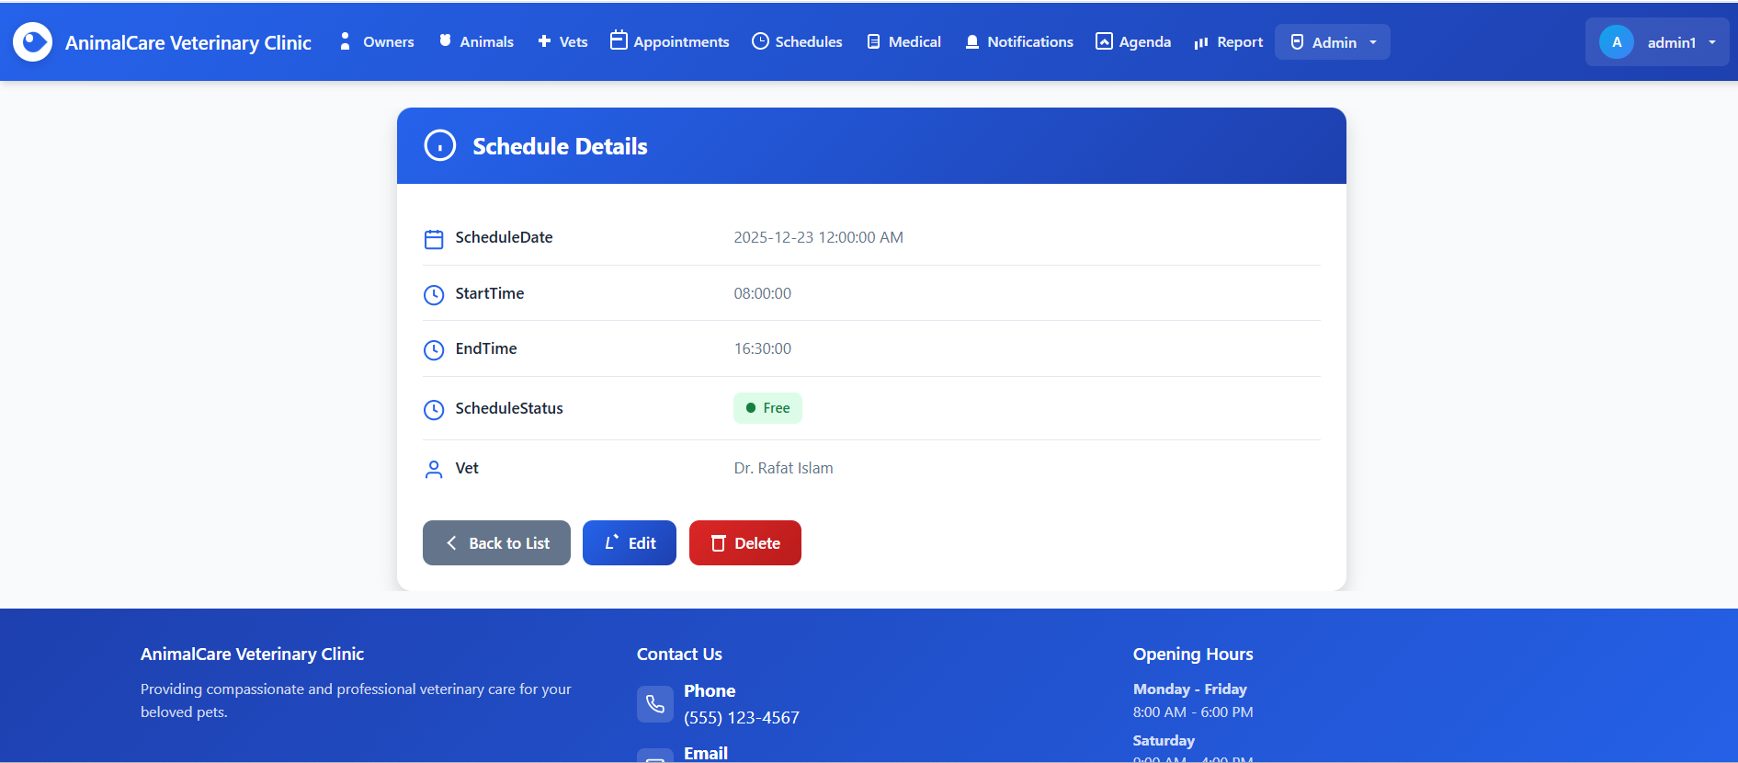
Figure 31 displays the detailed view of a veterinarian’s schedule. It shows the selected schedule date, the start and end times for that shift, and the current schedule status (e.g., Free). The assigned veterinarian is also listed. Users can navigate back to the schedule list, edit the schedule, or delete it using the action buttons at the bottom.

Figure 32 – Delete Schedule
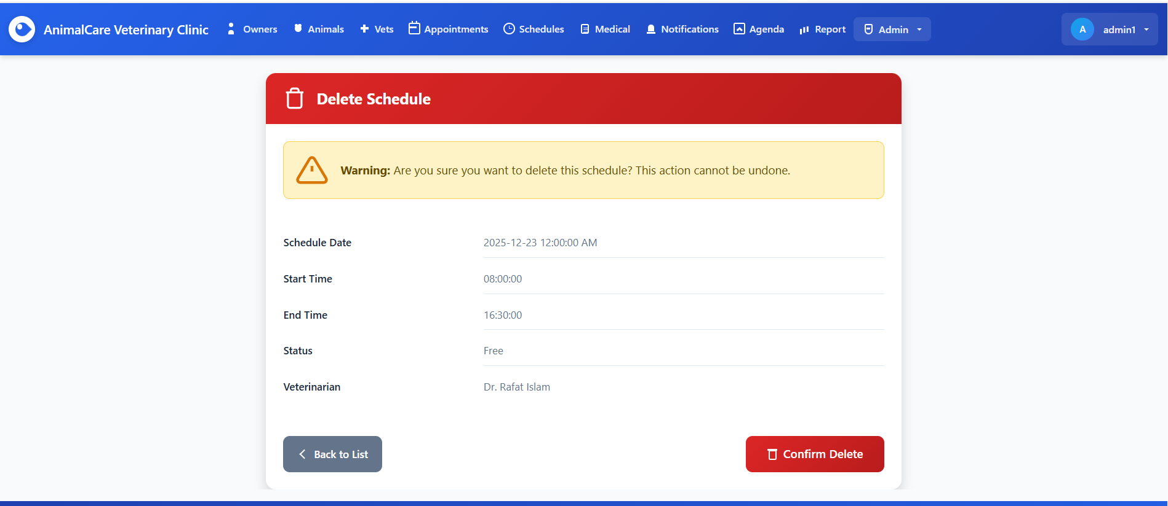
Figure 32 displays the confirmation page for deleting a veterinarian’s schedule. The page shows a warning message indicating that the action is permanent and cannot be undone. The schedule’s details, including the date, start and end times, status, and assigned veterinarian are listed for review before proceeding. Users may return to the list or confirm deletion using the action buttons at the bottom.

Figure 33 - Medical Histories Overview
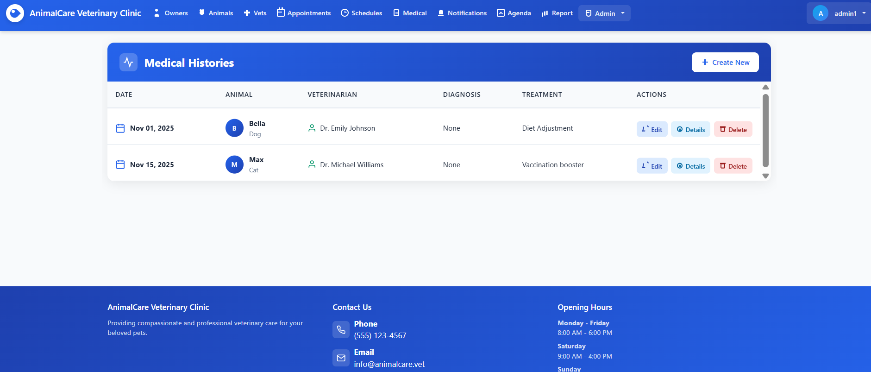
Figure 33 shows the Medical Histories page, which lists records of past medical visits for animals at the clinic. Each entry displays the visit date, animal name and type, assigned veterinarian, diagnosis, and treatment provided. Action buttons allow users to edit, view detailed information, or delete a medical history entry. A “Create New” button at the top enables adding new medical history records.

Figure 34 – Create Medical History Record
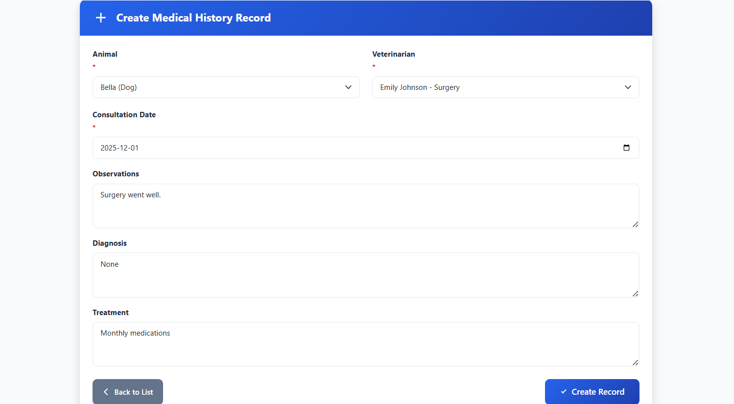
Figure 34 displays the form used to create a new medical history record for an animal. The user selects the animal and veterinarian, enters the consultation date, and provides details such as observations, diagnosis, and treatment. A “Create Record” button submits the information, while a “Back to List” button allows returning to the medical histories overview.

Figure 35 – Edit Medical History Record
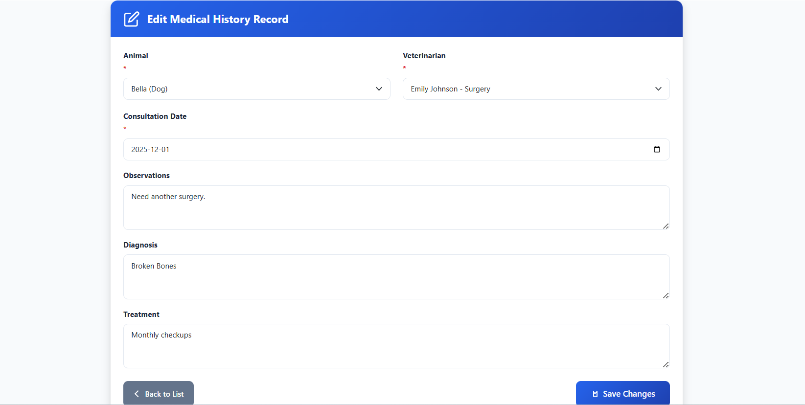
Figure 35 shows the interface used to update an existing medical history record. The form allows modification of the animal, veterinarian, consultation date, observations, diagnosis, and treatment details. The user can save the updated information using the “Save Changes” button or return to the list using the “Back to List” button.

Figure 36 – Medical History Details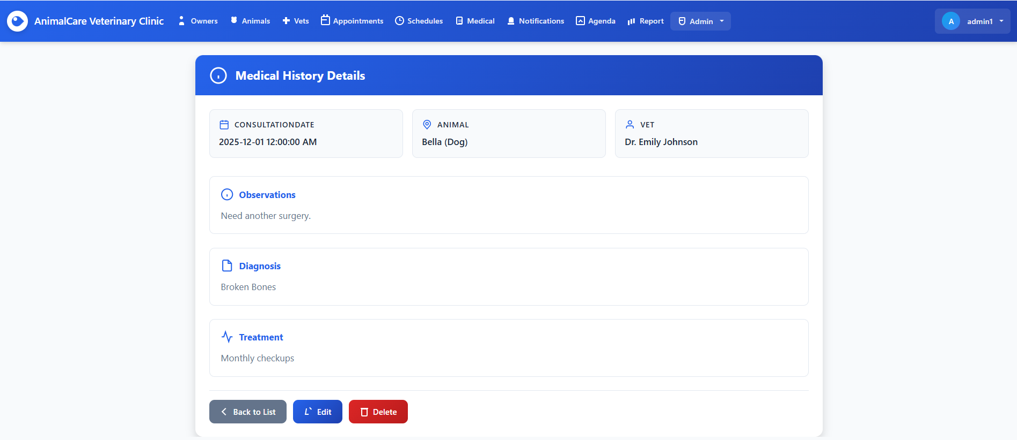
Figure 37 displays the detailed view of a medical history record for an animal. The page shows the consultation date, animal information, and the veterinarian involved. It also presents the recorded observations, diagnosis, and treatment in separate sections. At the bottom, options are provided to return to the list, edit the record, or delete it.

Figure 37 - Delete Medical History Confirmation Page
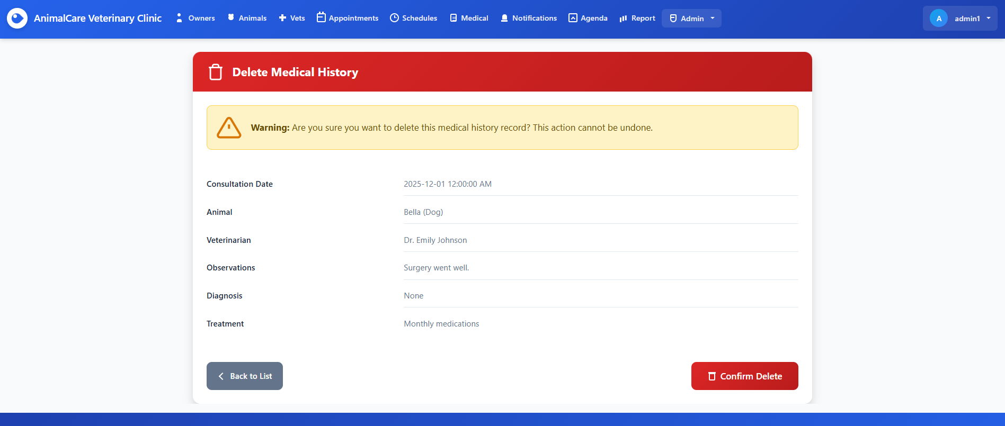
Figure 37 shows the confirmation interface used when deleting a medical history record. The page displays all relevant details of the selected record, including the consultation date, animal name and species, assigned veterinarian, observations, diagnosis, and treatment information. A yellow warning banner appears at the top of the page to inform the user that this action is permanent and cannot be undone. At the bottom, the user can either return to the list or confirm the deletion using the red “Confirm Delete” button, ensuring that accidental deletions are avoided through a clear and intentional confirmation process.

Figure 38 - Notifications Management Interface
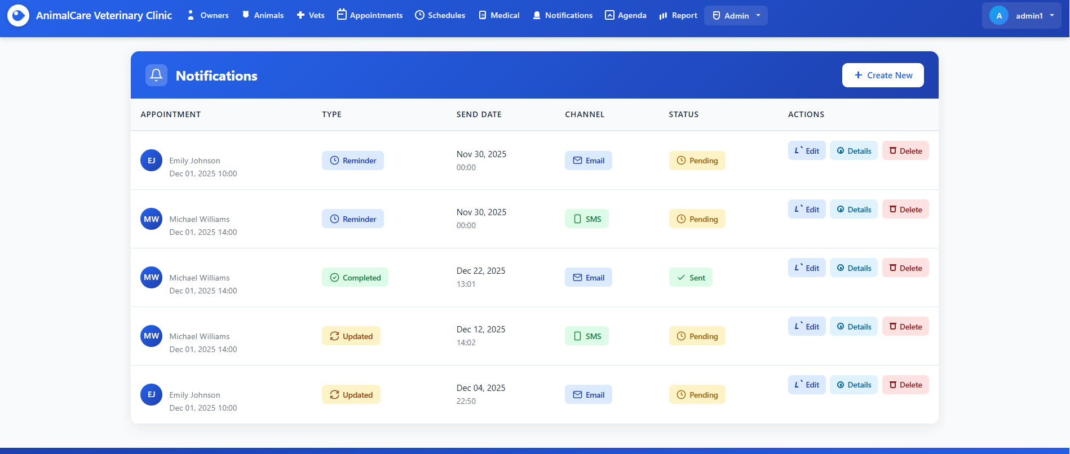
Figure 38 displays the Notifications Management page, where users can view, manage, and create automated notifications related to upcoming appointments. The table lists each notification along with key details such as the appointment information, notification type, scheduled send date, delivery channel (Email or SMS), and current status. Each row includes action buttons that allow users to edit the notification, view detailed information, or delete it from the system. A prominent “Create New” button is available at the top right corner, enabling staff to quickly generate new appointment reminders. This interface helps ensure timely communication with clients and supports efficient clinic workflow.

Figure 39 - Create New Notification Form
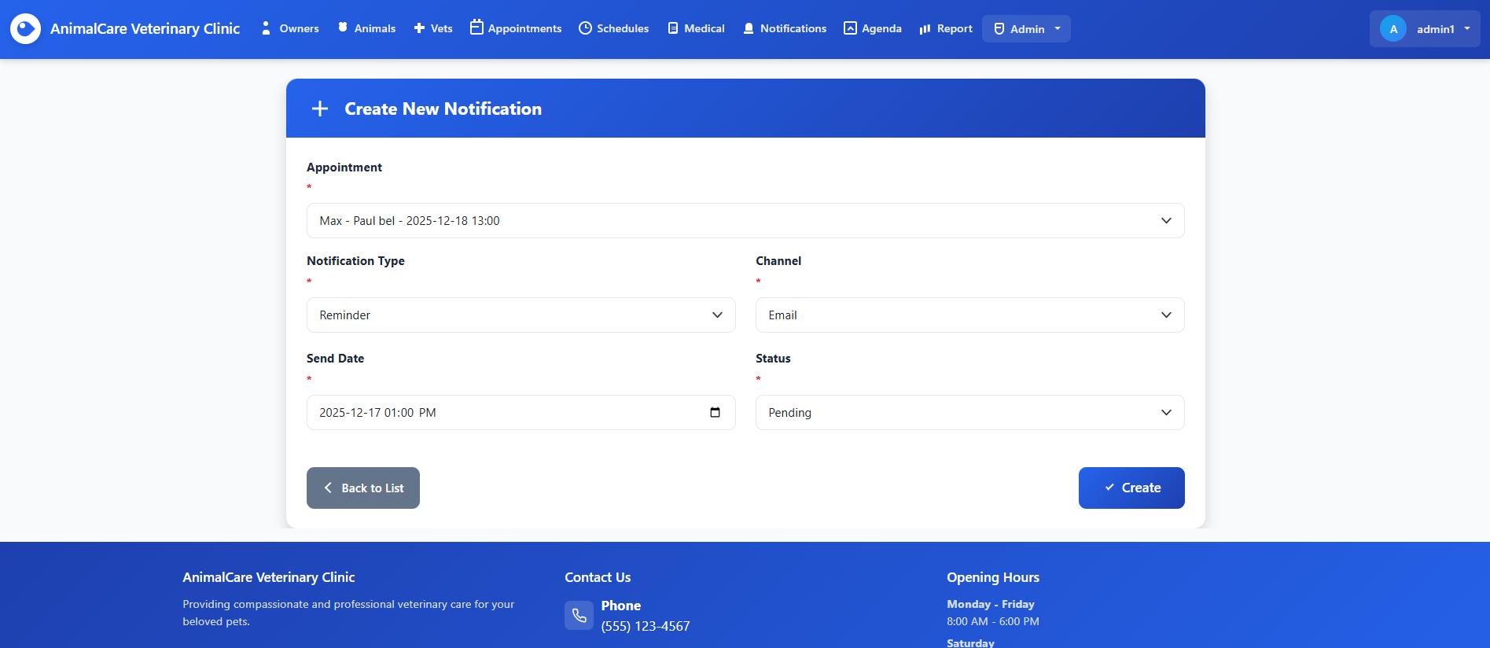
Figure 39 presents the interface for creating a new appointment notification within the system. Users can select the target appointment from a dropdown list, choose the notification type (such as Reminder), specify the delivery channel (Email or SMS), and assign a send date using the built-in date and time picker. The form also includes a status field, allowing staff to set the notification as Pending or another appropriate state. Once all required fields are completed, the user can finalize the action by clicking the “Create” button. This form streamlines the process of configuring timely reminders for clients, helping ensure effective communication and improved appointment management.

Figure 40 – Edit Notification Page
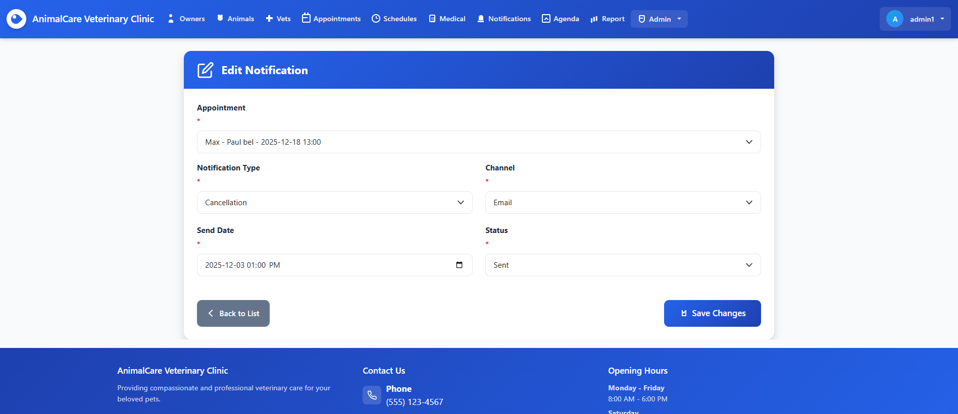
Figure 40 displays the interface used to modify an existing notification in the system. The form automatically loads the previously saved details, including the associated appointment, notification type, communication channel, scheduled send date, and current status. Users can update any of these values as needed, such as changing the notification type from a reminder to a cancellation or modifying the delivery channel. After adjustments are made, the staff member can save the updated information by selecting the “Save Changes” button. This feature ensures flexibility and accuracy in managing communication with clients, allowing the clinic to adapt notifications when appointment details or circumstances change.

Figure 41 – Notification Details Page
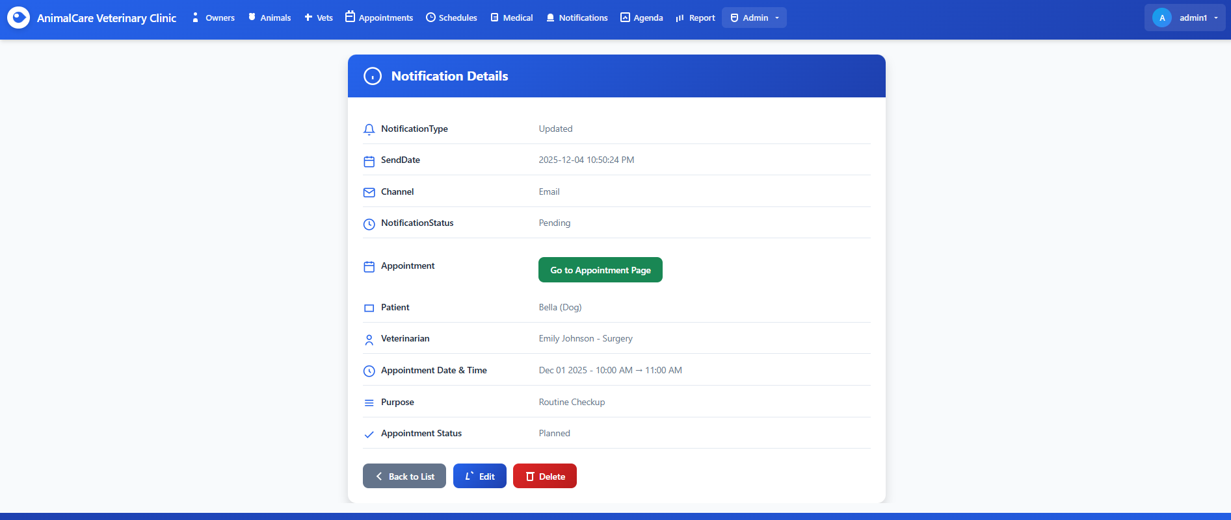
Figure 41 presents the Notification Details page, which displays all information associated with a specific notification entry. This page allows administrators to review the notification type, scheduled send date and time, communication channel, and the status of the notification (for example, Sent or Pending). The page also identifies the appointment linked to the notification. From this screen, users can choose to return to the notification list, edit the current notification, or permanently delete it. This detailed view ensures that staff members can verify communication records and manage follow-ups effectively.

Figure 42 – Delete Notification Page
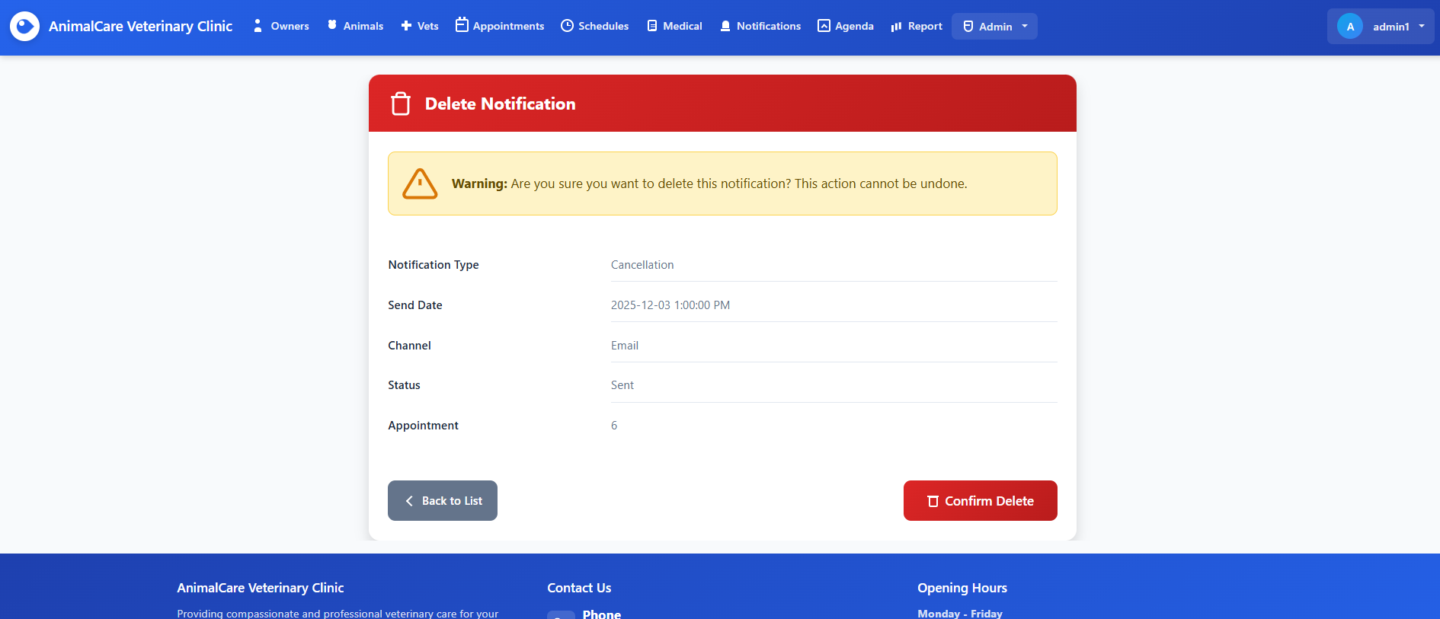
Figure 42 displays the Delete Notification page, which is used to confirm the removal of a specific notification record. At the top, a prominent warning message alerts the administrator that deleting this notification is irreversible. The page summarizes all key details of the notification, including the notification type, scheduled send date, communication channel, status, and the associated appointment. This review step helps prevent accidental deletions. At the bottom of the screen, the user can either go back to the notification list or proceed by selecting Confirm Delete to finalize the removal.

Figure 43 - Create Notification Page with Validation Errors
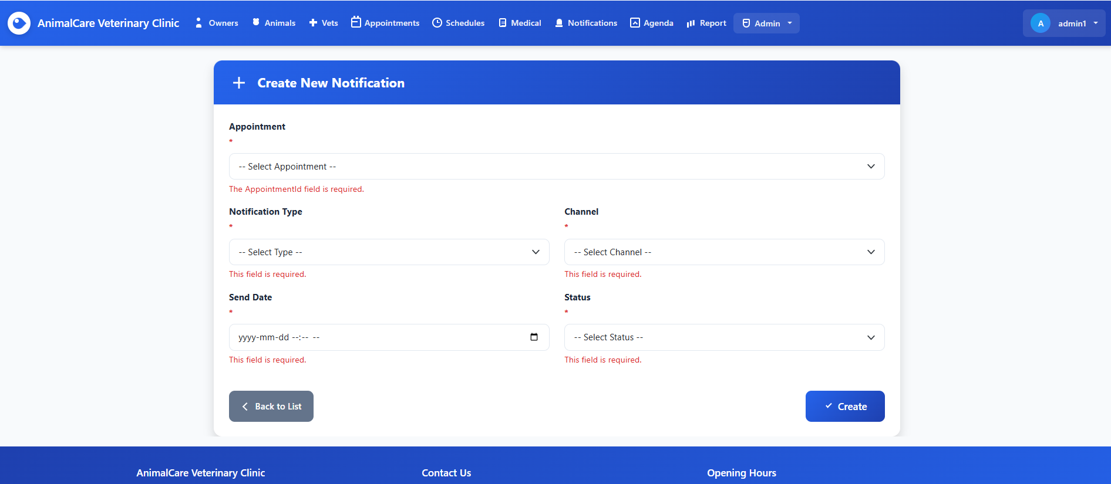
Figure 43 shows the Create New Notification page when the user submits the form without filling in the required fields. Each mandatory input : Appointment, Notification Type, Channel, Send Date, and Status is highlighted with a red validation message indicating that the field is required. This validation ensures that notifications cannot be created without complete and accurate information. The user can either correct the missing fields or return to the list using the Back to List button. The design provides immediate feedback while maintaining a clean and structured layout.

Figure 44 – Daily Agenda View
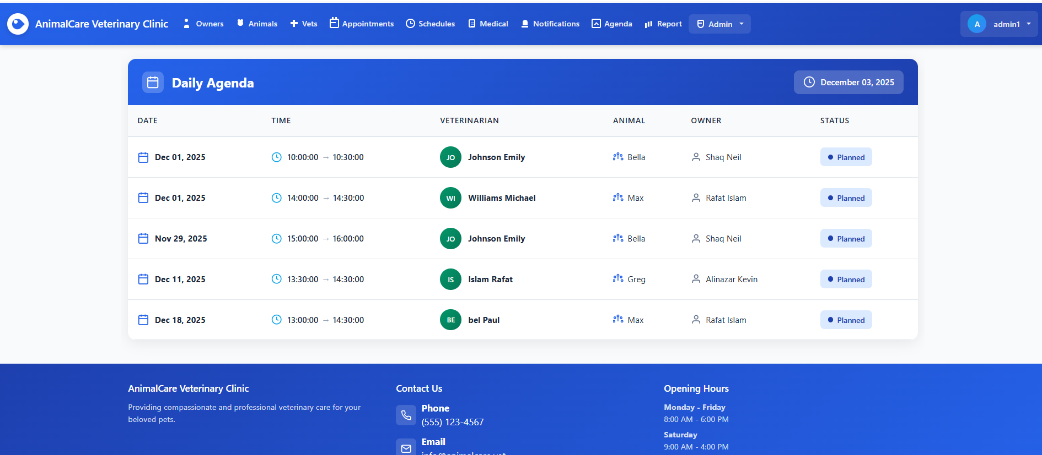
Figure 44 presents the Daily Agenda interface, which provides administrators and staff with a clear overview of all scheduled appointments for a selected date. Each entry displays essential appointment details, including the appointment date, time range, assigned veterinarian, the animal being treated, the pet owner, and the current appointment status. The layout uses intuitive icons and color-coded status badges, allowing users to quickly interpret schedule information at a glance. A date selector at the top-right corner enables easy navigation between different days, helping staff efficiently plan clinic operations and manage workload.

Figure 45 – Monthly Reports View
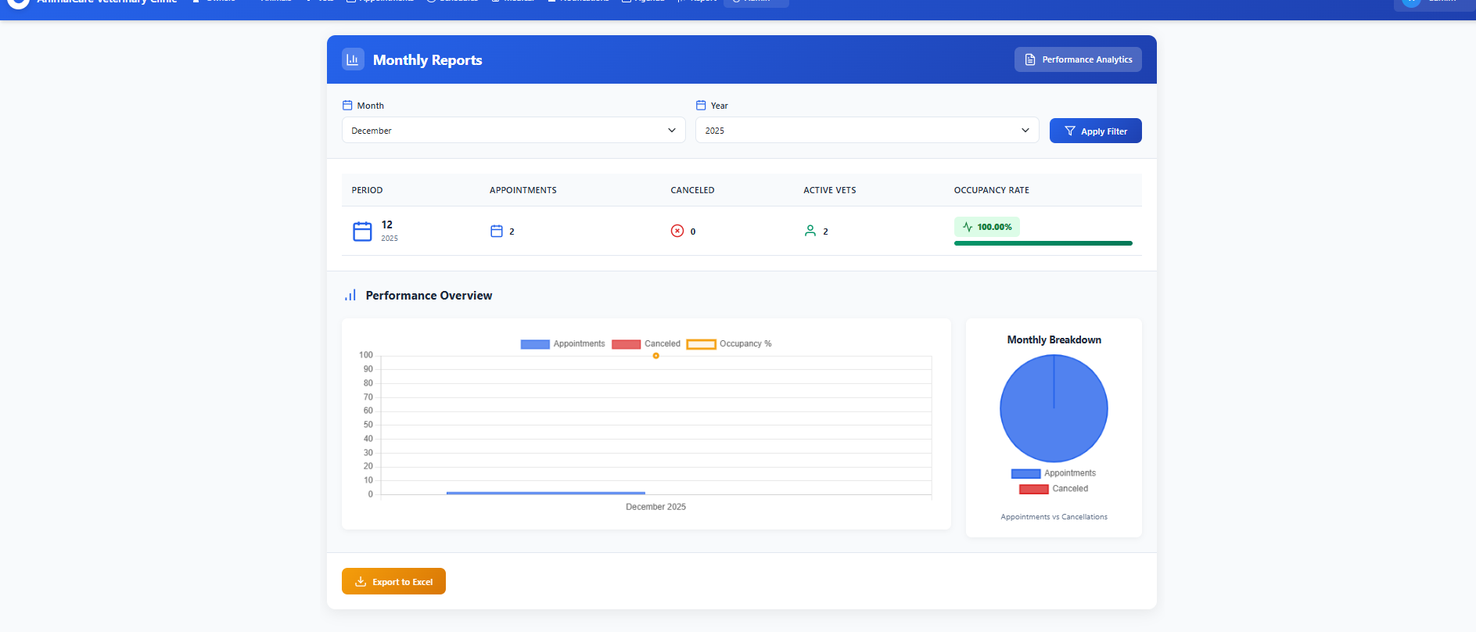
Figure 45 displays the Monthly Reports interface, which provides administrators with a consolidated overview of clinic performance across different months. Each row represents a reporting period and highlights key operational metrics, including the number of appointments completed, cancellations, and the count of active veterinarians. The occupancy rate is visually represented through a progress bar and percentage indicator, allowing staff to quickly interpret clinic utilization trends. This view helps administrators monitor workload distribution, identify seasonal patterns, and support data-driven decision-making regarding resource planning and performance optimization.

Figure 46 – User Accounts Management View
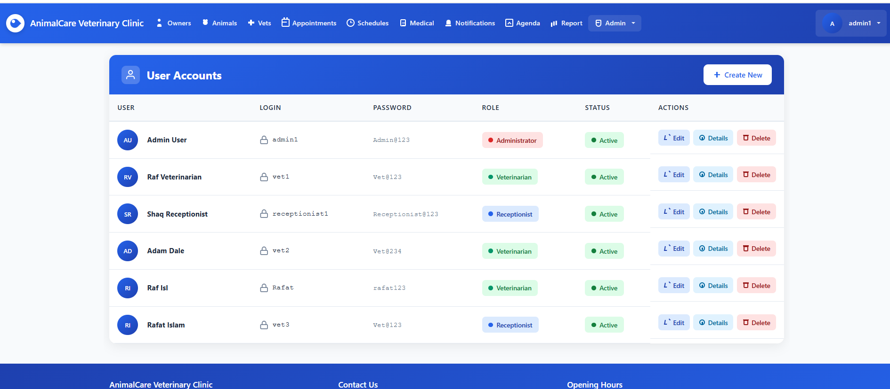
Figure 46 shows the User Accounts management interface, where administrators can oversee all system users and their associated access roles. Each row displays essential information, including the user’s name, login credentials, assigned role (Administrator, Veterinarian, or Receptionist), and account status. Action buttons allow administrators to quickly edit user details, view full profiles, or remove accounts when necessary. This view centralizes user permissions and ensures secure, role-based access throughout the application, supporting effective administrative control and system integrity.

Figure 47 – Create User Account View
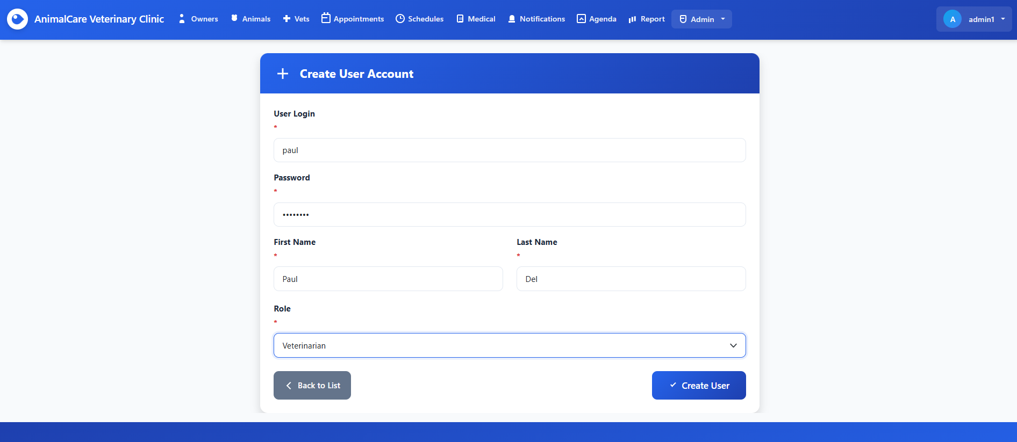
Figure 47 displays the Create User Account interface, where administrators can register new system users. The form includes required fields such as the user login, password, first name, last name, and assigned role. Dropdown selections ensure that each user is linked to an appropriate access level like Veterinarian, Receptionist, or Administrator. This streamlined layout enables administrators to quickly add personnel while maintaining proper role-based security across the application.

Figure 48 – Edit User Account
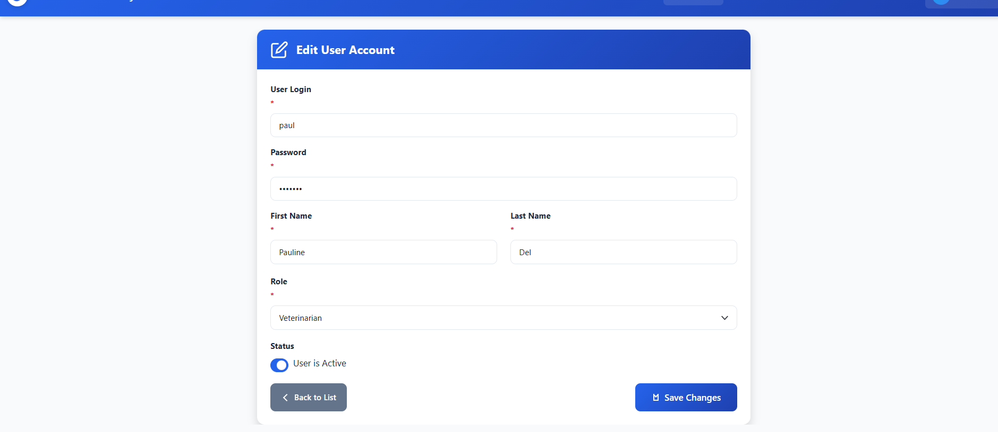
Figure 48 shows the Edit User Account interface, where administrators can modify an existing user’s information. The form is pre-populated with the user’s current data, including login, password, first name, last name, assigned role, and account status. The status toggle allows administrators to activate or deactivate the account instantly. The design follows the same consistent UI theme as the rest of the application, featuring a clear layout, labels, required field indicators, and action buttons for saving or returning to the user list.

Figure 49 - User Account Details
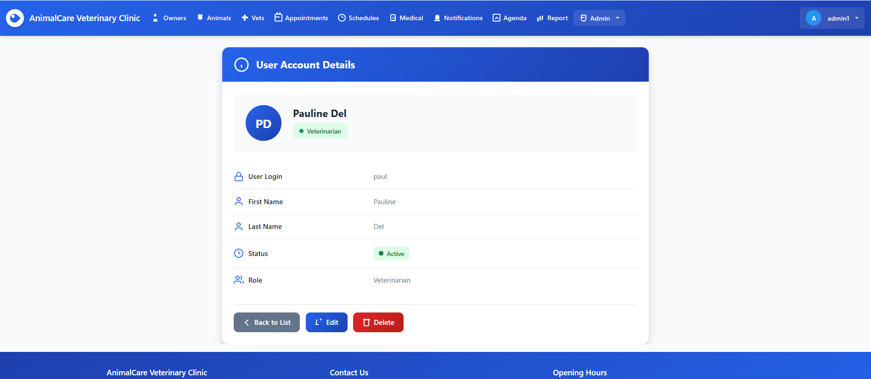
Figure 49 presents the User Account Details page, where administrators can view the complete profile information of a selected user. This page provides a clean summary of all relevant user attributes, including identity, login credentials, role, and account status. The user’s initials and full name are displayed prominently at the top, along with a colored badge indicating the assigned role. Below this section, the page displays each user property in a structured list format, using clearly identifiable icons for improved readability.

Figure 50 – Delete User Account
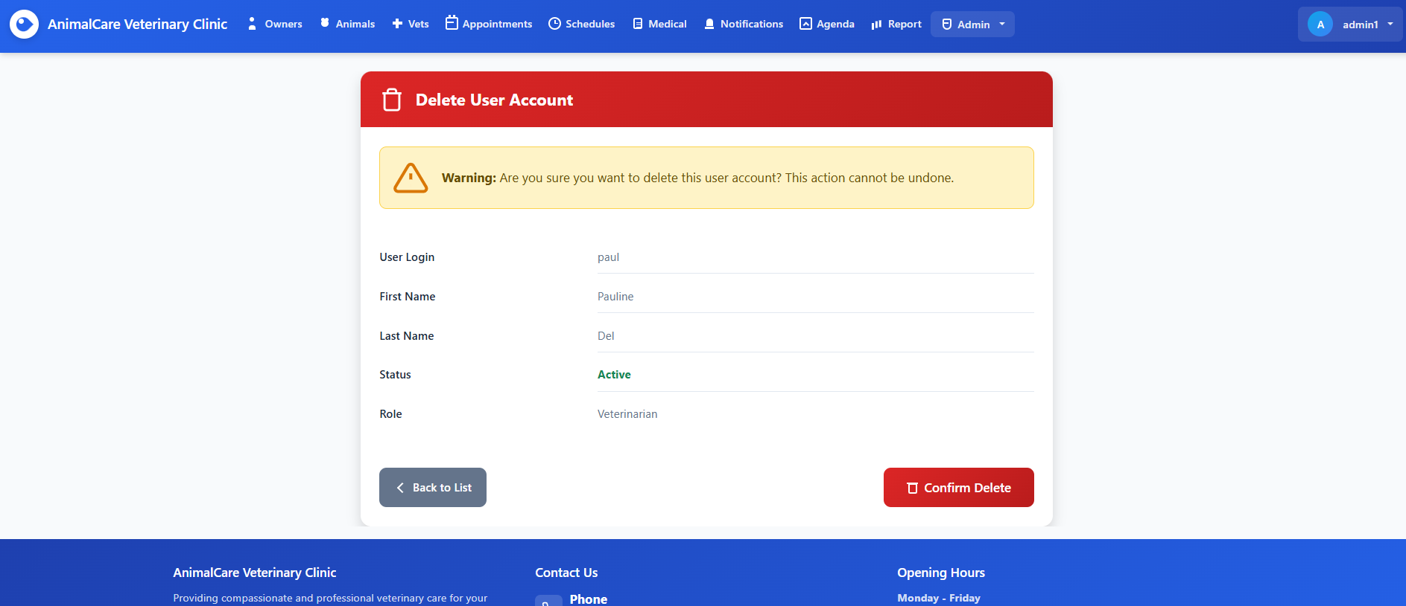
Figure 50 displays the Delete User Account confirmation page, which is shown when an administrator attempts to permanently remove a user from the system. This screen serves as a safeguard against accidental deletions by presenting a clear warning message and requiring explicit confirmation. At the top, a red header and warning banner emphasize the seriousness of the action, stating that deletion is irreversible. Below the warning, the user’s essential details are displayed in a read-only format so administrators can verify the correct account before proceeding.

Figure 51 – User Roles List
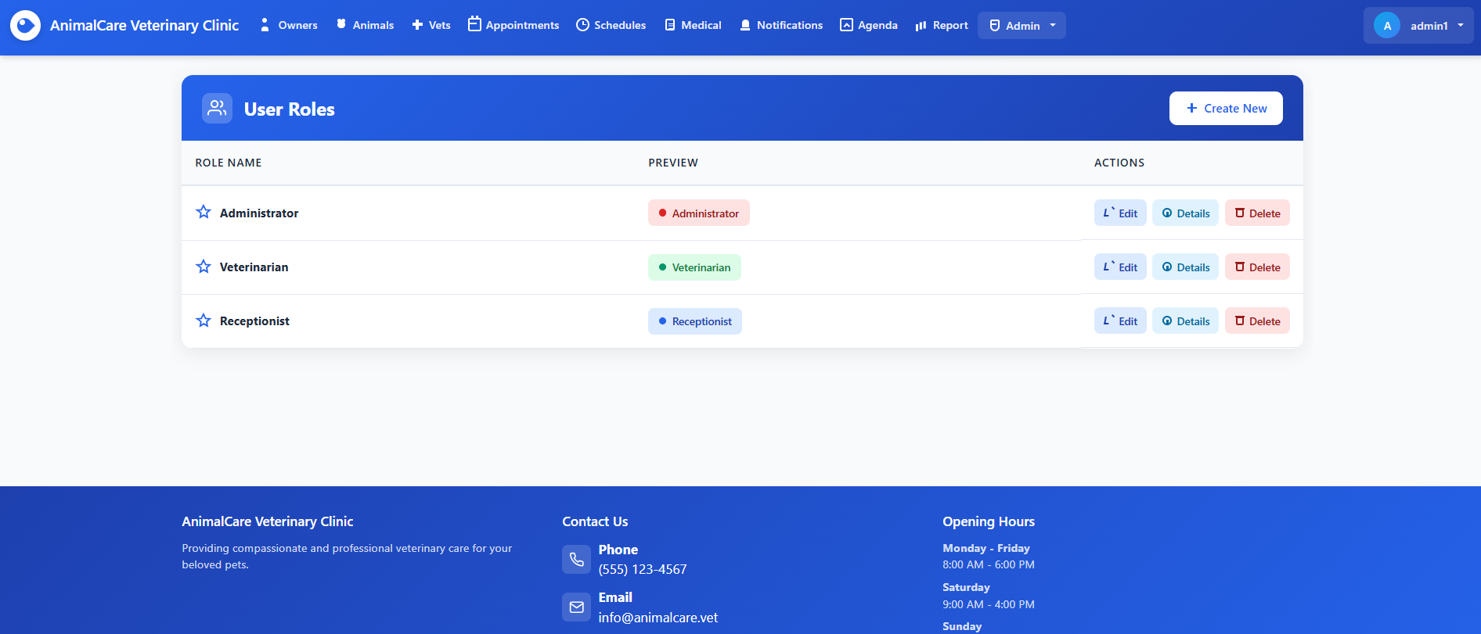
Figures 50 displays all defined roles in the system, including Administrator, Veterinarian, and Receptionist. Each role is shown with its name, a colored preview badge for quick visual identification, and a set of management actions such as Edit, Details, and Delete. These actions allow administrators to modify role information, view role details, or remove a role when appropriate. A Create New button is available at the top-right corner, enabling administrators to easily add additional roles. This page provides a streamlined interface for managing user permissions and maintaining the application's access structure.

Figure 52 – Create New Role
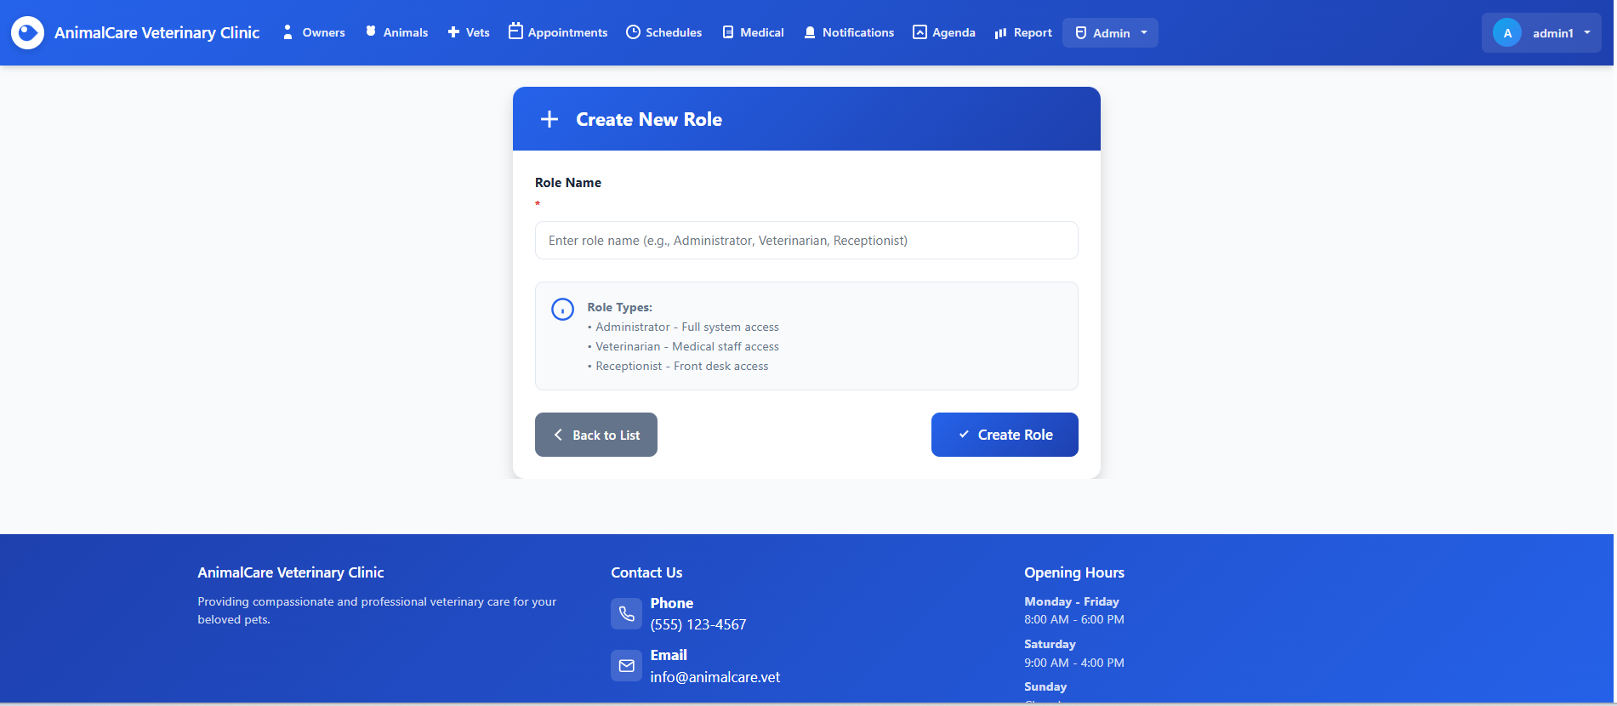
Figure 52 presents a simple and intuitive form that allows administrators to add a new system role. The interface includes a required text field where the user enters the role name, along with a helpful guideline box explaining typical role types such as Administrator, Veterinarian, and Receptionist, and the level of access each one provides. Users can return to the roles list using the Back to List button or finalize the creation of the new role by selecting the Create Role button. This page ensures that role management remains flexible, clear, and easy to maintain.

Figure 53 – Edit Role
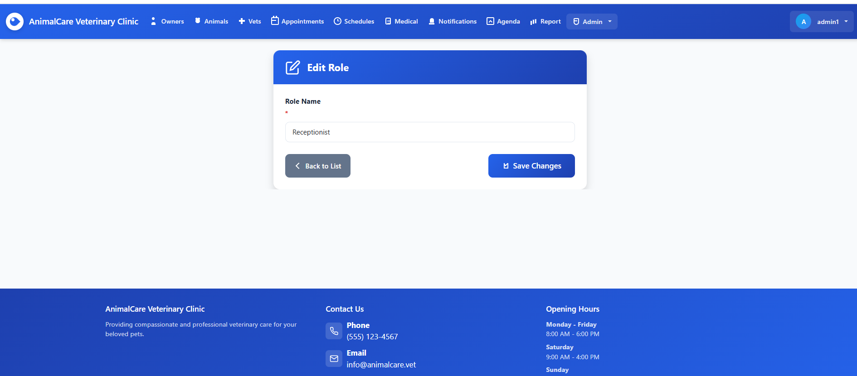
Figure 53 displays a straightforward form that allows administrators to update an existing role’s name. The interface contains a single required input field pre-filled with the current role name, ensuring clarity and preventing mistakes during modification. Users can return to the main roles list using the Back to List button or apply the changes by selecting the Save Changes button. This page maintains a simple layout focused on accuracy and efficiency when managing system roles.

Figure 54 – Role Details
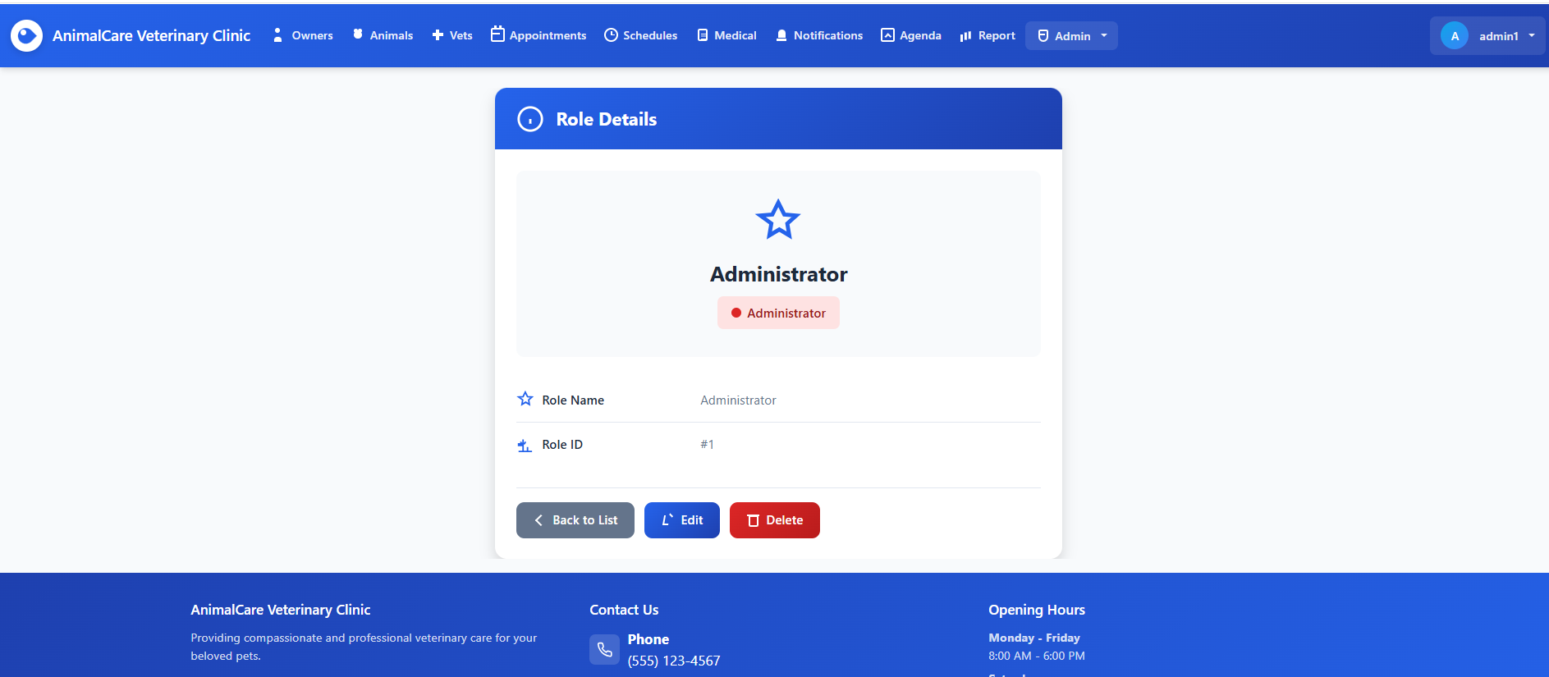
Figure 54 presents an overview of a selected system role, displaying key information such as the role name and unique role ID in a structured and visually clear layout. The top section highlights the role with an icon and a colored badge, reinforcing the role type for quick recognition. Below, the details are shown in labeled rows for easy readability. At the bottom of the page, administrators are provided with three actions: Back to List to return to the roles overview, Edit to modify the role, and Delete to remove it from the system. The page is designed for clarity and efficient role management.

Figure 55 – Delete Role
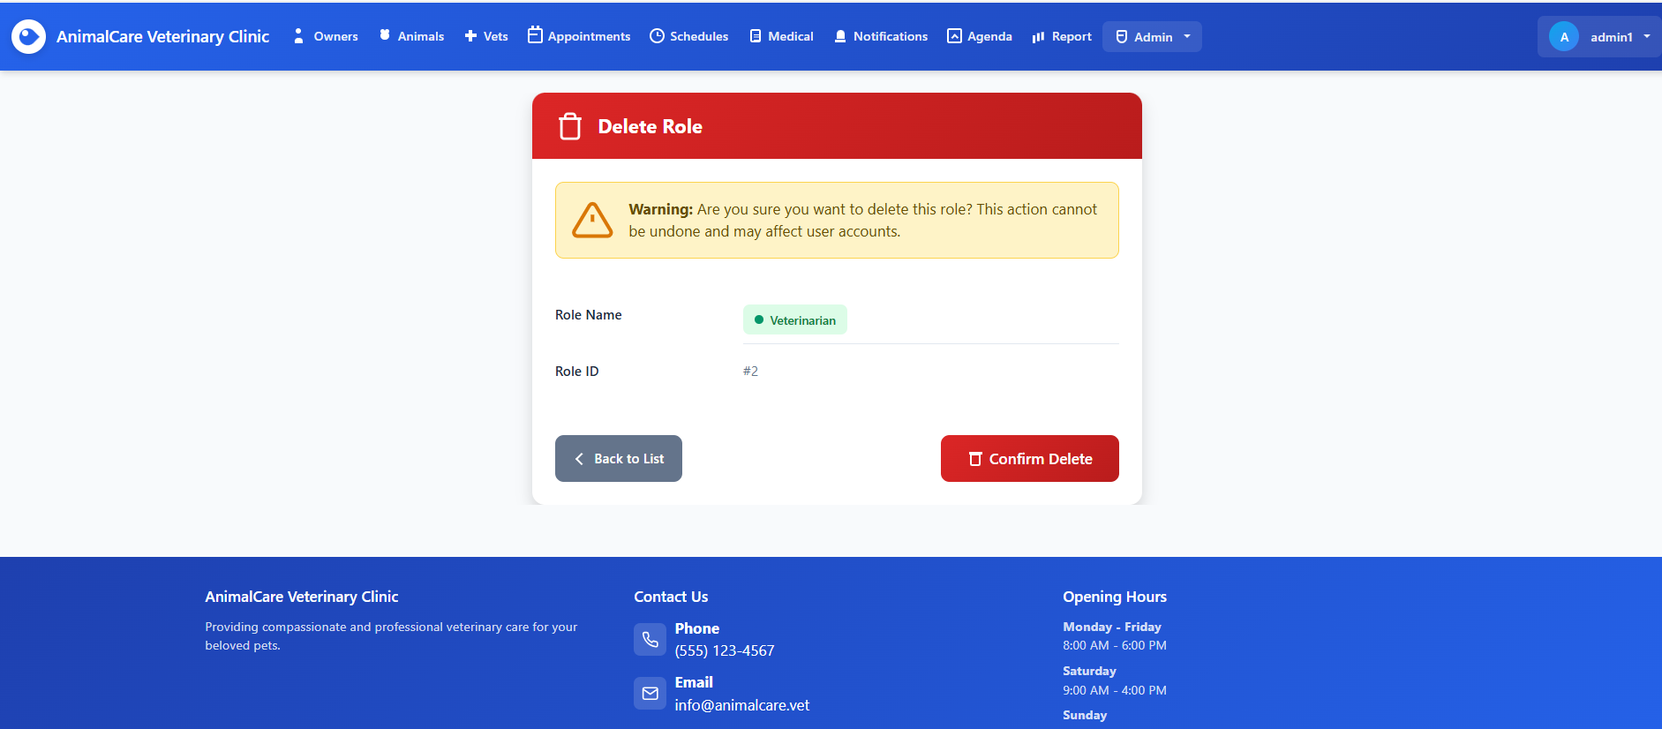
Figure 55 displays a confirmation page prompting the administrator to verify the deletion of a selected system role. A highlighted warning message explains that deleting this role is irreversible and may impact any user accounts associated with it. The page presents key role information such as the role name and role ID to ensure the correct item is being removed. At the bottom, the user is offered two actions: Back to List to cancel the operation, or Confirm Delete to proceed with permanently removing the role. The layout prioritizes clarity and caution to prevent accidental deletion.

Figure 56 – Create New Role (Validation Error)
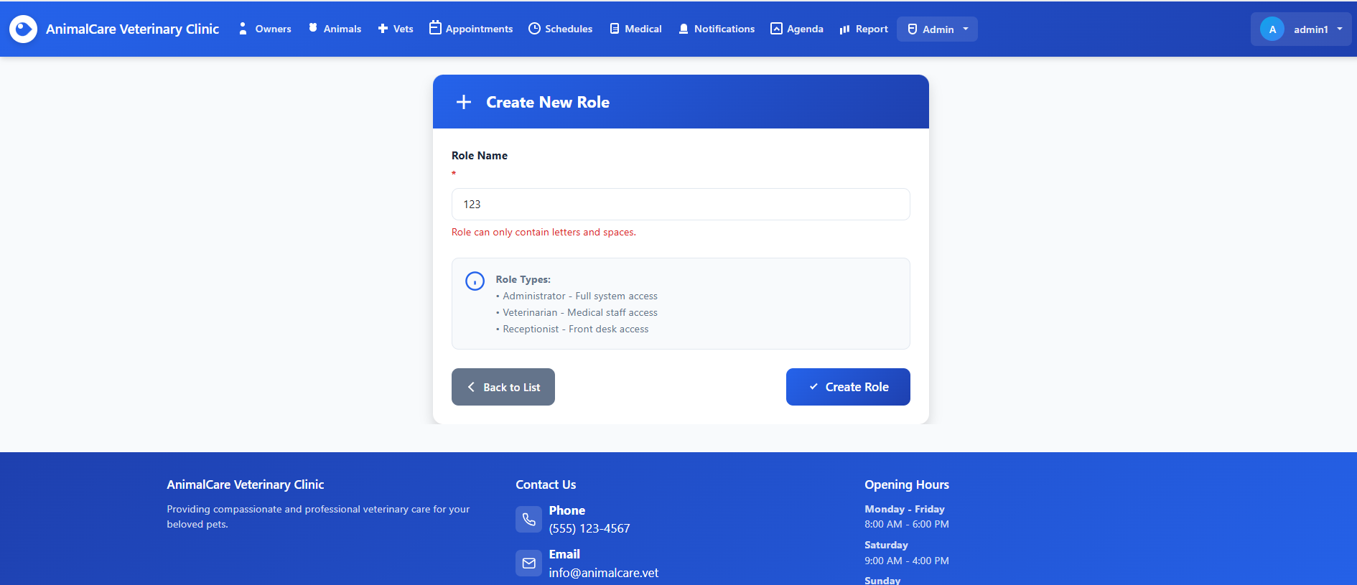
Figure 56 shows the role creation form displaying a validation message after the user attempts to submit an invalid role name. Although the user enters “123,” the system immediately flags the input, indicating that role names must contain only letters and spaces. The form highlights this error beneath the text field while still displaying the predefined role type descriptions to guide proper naming conventions. Navigation buttons allow the user to return to the role list or correct the error and retry role creation, ensuring data integrity and preventing invalid entries in the system.

